

MOVILIGHT LED BEAM 200
User Manual – Version 1.0
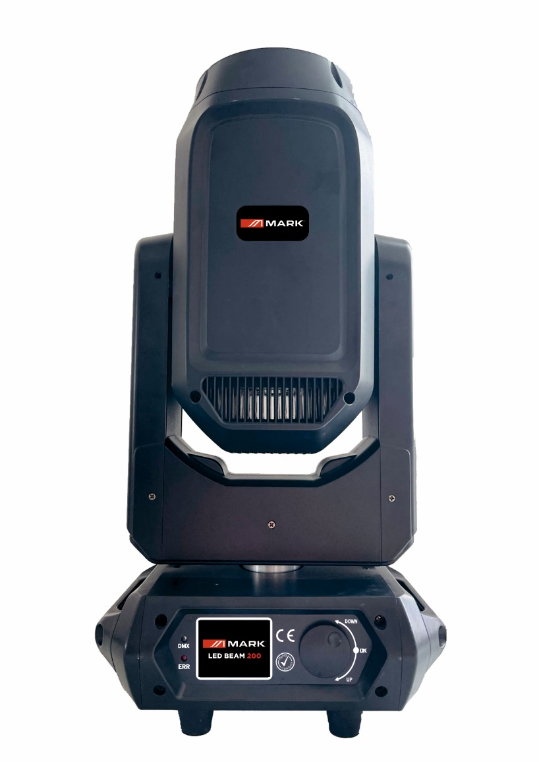

SAFETY INSTRUCTIONS
1. Read the instructions of this manual.
2. Keep these instructions in a safe place.
3. Heed all warnings.
4. Follow all instructions.
5. Please, respect your country safety regulations.
6. Don’t use this device close to the water or high humidity places. Clean only with dry cloth.
7. Don’t install near any heat sources such as radiators, heat registers, stoves, or other apparatus (including amplifiers) that produce heat. Make certain that the equipment is always installed so that is cooled and can’t overheat.
8. Don’t block any ventilation openings. Install in accordance with the manufacturer’s instructions.
9. Protect the power cord from being walked on or pinched, particularly at plugs, convenience receptacles, and the point where they exit from the apparatus.
10. Only use attachments/accessories specified by MARK.
11. Unplug this device during lightning storms or when unused for long periods of time.
12. The technical service is required when the device has been damaged in any way, such as power supply cord or plug is damaged, liquid has been spilled or objects have fallen into the device, doesn’t operate normally or has been dropped.
13. To completely disconnect this apparatus from the AC mains, disconnect the power supply cord plug from the AC receptacle.
14. The mains plug of the power supply cord shall remain readily operable.
15. WARNING – to reduce the risk of fire or electric shock, don’t expose this device to rain or humidity.
16. Don’t expose this equipment to dripping or splashing and ensure that no objects filled with liquids, such as vases, are placed on the equipment.

OVERVIEW
MOVILIGHT LED BEAM 200 is a moving head that incorporates the latest lighting technology ultra-bright 200W LED. Thanks to its precise motors, the movements in both axis are really fast. It can offer intense scenes of mixing colours and effects.
MOVILIGHT LED BEAM 200 combines a wide range of functionalities. With 14 colour wheel, gobo wheel (13 gobos and vibration effect). It includes CTO correction filter, double rotating prism, functions such as strobe and focus. Thanks to its LCD touch screen and encoder that allows navigation through a complete menu system, it can be operated in stand-alone mode.
The device incorporates a PowerCON power connector and XLR 3 type connection for DMX signal input and output. MOVILIGHT LED BEAM 200 can be controlled through the DMX protocol and work with independent programs both by audio or as master / slave. If the device is working under the DMX protocol, it is possible to use 16 and 20 channels, increasing the characteristics and effects such as linear dimmer, strobe, and control colour.
MOVILIGHT LED BEAM 200 is made of ABS plastic, reducing its weight, and offering a hard shell against impacts. On the front panel there is a touch screen to navigate and program the menu and an encoder for a high speed operation. Among the configurable functions from the menu, it is worth highlighting the inversion of Pan and Tilt axes, the audio sensitivity or the selection of modes of use.
Technical data:
Power supply | AC 100V-240V 50/60 Hz
Consumption | 300W
Light source | 200W LED
Control modes | DMX 512, Audio, Auto, Master-Slave, Manual
DMX channels | 16 and 20 channels
PAN/TILT | 540º +16 bit fine  270º +16 bit fine
Dimmer | 0-100%
Connections | XLR 3 (male/female) for DMX  2x PowerCON (male/female) connector for main supply
Dimensions (L x W x D) | 400x330x510 mm
Weight | 16.5 Kg

Features:
200W LED.
Control modes: DMX512, Audio, Auto, Master/Slave.
Channels DMX: 16 & 20 channels
Dimmer: 0-100% dimmer lineal.

INSTALLATION
This product is only suitable for professional use. MOVILIGHT LED BEAM 200 is designed only for indoor use. This device should be kept dry to avoid moisture, overheating or dusty environment. Ensure that the unit does not take into contact with water or any other liquid.
MOVILIGHT LED BEAM 200 can be placed in a stable surface or stand but the common operating mode is rigging it in a truss system. Please, check and follow the next recommendations for a safe use of this device:
- The truss system must be built in a way that it can hold 10 times the weight of all rigging elements for 1 hour without any harming deformation.

- The fixation system (clamps or hangs) must be able to hold 10 times the weight of the device.

- The device must always be secured with a safety attachment, e.g. steel cable.

- The operator must check that the installation meets the safety standards and the device installation is approved by a skilled person.

DMX Connection.
The DMX cable must use the professional shielded twisted pair cable. Standard loudspeaker cable is not reliable to control the long-range data. 24AWG cable is suitable for up to 300 meters long-distance signal transmission; for longer distances, a DMX 512 signal amplifier should be used.
Don’t overload the connection. One continuous connection can only support up to 30 devices. It is advisable to use a DMX splitter in order to distribute the signal without losing its integrity.

Connect the DMX512 input terminal to the controller. After that, connect the output terminal to the next device. Repeat this step with all fixtures in the chain. To prevent system errors, the last device in a DMX chain needs to be equipped with a terminating resistor (120 Ohm, 1/4 Watt).

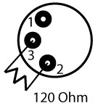
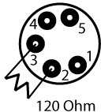
Pin occupation
Pin 1: Ground
Pin 2: Pin -
Pin 3: Pin +
To connect more than one unit in a chain, please, follow this picture. The output of the first unit must provide to the next DMX input of the signal, this way it is possible to send the signal to all the devices in the chain.

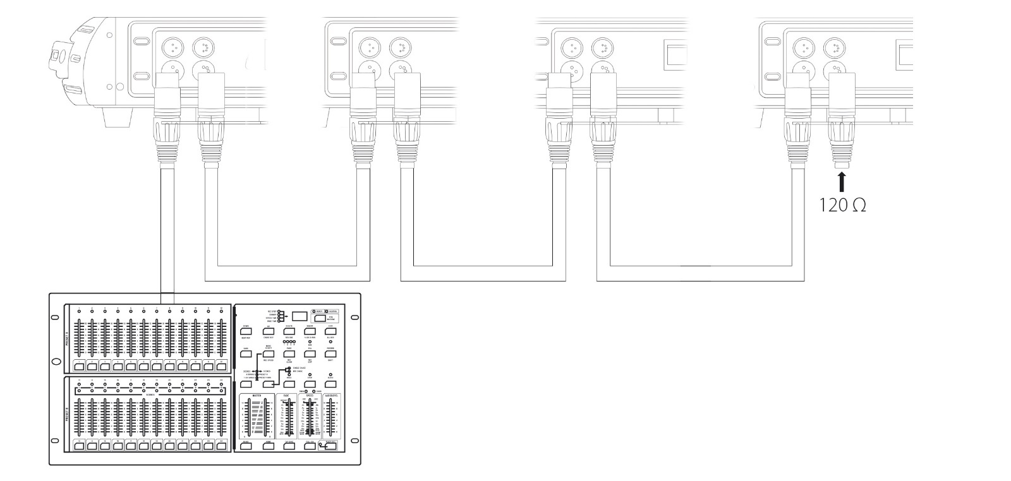

ADVANCED USE
CONTROL PANEL
MOVILIGHT LED BEAM 200 allows to get configurated in different ways thanks to its tactil panel and encoder.
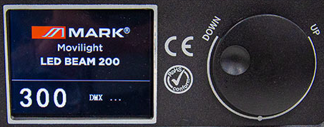
Press the ENCODER DOWN/UP until you get to the desired function (according to the following chart), and push down to confirm your selection, you can also use the touch screen.
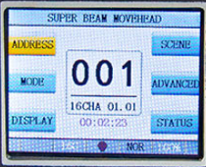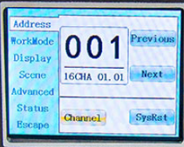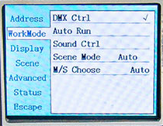
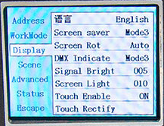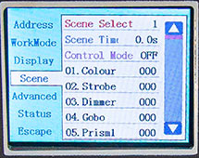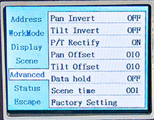
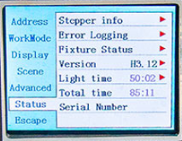

SETUP MENU
The following table shows all the options to configure the MOVILIGHT LED BEAM 200 in the menu interface:

DISPLAY | VALUE | Function
Address | 001-512 | DMX address selected
Address | 16/20 Ch | Channels mode 16/20
WorkMode | DMX CTRL | DMX mode
WorkMode | AUTO RUN | Auto mode
WorkMode | SOUND CTRL | Sound mode
WorkMode | SCENE MODE | 10 scenes selection
WorkMode | M/S CHOOSE | Master/Slave/Auto
Display | Language | Choose language (Chinese/English)
Display | Screen Saver | 4 modes and OFF
Display | Screen Rot | Rotate 180º the screen
Display | DMX Indicate | 3 modes
Display | Signal Bright | 1 to 10
Display | Screen light | Screen light level 1 to 10
Display | Touch Enable | Touch Screen ON/OFF
Display | Touch Rectify
Scene | Scene Select | 1 to 10
Scene | Scene Time | Up to 25,5 seconds
Scene | Control Mode | ON/OFF
Scene | - Colour
Scene | - Strobe
Scene | - Dimmer
Scene | - Gobo
Scene | - Prism1
Scene | - Prism1 Rotate
Scene | - Prism 2 Rotate
Scene | - Frost
Scene | - Focus
Scene | - Pan
Scene | - Pan Fine
Scene | - Tilt
Scene | - Tilt Fine
Scene | - Macro
Scene | - Reset
Scene | - Empty
Scene | - PT Speed
Scene | - Color Speed
Scene | - Focus Speed
Scene | - Gobo Speed
Advanced | Pan Invert | ON/OFF
Advanced | Tilt Invert | ON/OFF
Advanced | P/T Rectify | ON/OFF
Advanced | Pan Offset | 04-150
Advanced | Tilt Offset | 04-48
Advanced | Data Hold | ON/OFF
Advanced | Scene Time | 1-255
Advanced | Factory Settings | Reset to factory settings
Status | Stepper Info
Status | Error Logging
Status | Fixture Status | System Info
Status | Version
Status | Light Time | LED using hours
Status | Total Time | Total function hours
Status | Serial Number

CHANNEL TABLE
The following table shows the function of the DMX channels for 16/20 CHANNELS mode:

CH16 | CH20 | Function | Value | Description
CH1 | CH1 | Colour | 0-4 | White
CH1 | CH1 | Colour | 5-9 | White+Red
CH1 | CH1 | Colour | 10-14 | Red
CH1 | CH1 | Colour | 15-19 | Red+Yellow
CH1 | CH1 | Colour | 20-24 | Yellow
CH1 | CH1 | Colour | 25-29 | Yellow+Blue
CH1 | CH1 | Colour | 30-34 | Blue
CH1 | CH1 | Colour | 35-39 | Blue+Green
CH1 | CH1 | Colour | 40-44 | Green
CH1 | CH1 | Colour | 45-49 | Green+Orange
CH1 | CH1 | Colour | 50-54 | Orange
CH1 | CH1 | Colour | 55-59 | Orange+CBO
CH1 | CH1 | Colour | 60-64 | CBO
CH1 | CH1 | Colour | 65-69 | CBO+Light Green
CH1 | CH1 | Colour | 70-74 | Light Green
CH1 | CH1 | Colour | 75-79 | Light Green+Pink
CH1 | CH1 | Colour | 80-84 | Pink
CH1 | CH1 | Colour | 85-89 | Pink+Cyan
CH1 | CH1 | Colour | 90-94 | Cyan
CH1 | CH1 | Colour | 95-99 | Cyan+Purple
CH1 | CH1 | Colour | 100-104 | Purple
CH1 | CH1 | Colour | 105-109 | Purple+CTO
CH1 | CH1 | Colour | 110-114 | CTO
CH1 | CH1 | Colour | 115-119 | CTO+Ambar
CH1 | CH1 | Colour | 120-124 | Ambar
CH1 | CH1 | Colour | 125-129 | Ambar+UV
CH1 | CH1 | Colour | 130-134 | UV
CH1 | CH1 | Colour | 135-139 | UV+White
CH1 | CH1 | Colour | 140-197 | Rotate forward (fast to slow)
CH1 | CH1 | Colour | 198-255 | Rotate reverse (slow to fast)
CH2 | CH2 | Strobe | 0-3 | Dark
CH2 | CH2 | Strobe | 4-127 | Pulse strobe slow to fast
CH2 | CH2 | Strobe | 128-191 | Fade strobe slow to fast
CH2 | CH2 | Strobe | 192-251 | Rand strobe slow to fast
CH2 | CH2 | Strobe | 252-255 | Open
CH3 | CH3 | Dimmer | 0-255 | 0-100% dimmer
CH4 | CH4 | Gobo | 0-4 | White
CH4 | CH4 | Gobo | 5-9 | Gobo1
CH4 | CH4 | Gobo | 10-14 | Gobo2
CH4 | CH4 | Gobo | 15-19 | Gobo3
CH4 | CH4 | Gobo | 20-24 | Gobo4
CH4 | CH4 | Gobo | 25-29 | Gobo5
CH4 | CH4 | Gobo | 30-34 | Gobo6
CH4 | CH4 | Gobo | 35-39 | Gobo7
CH4 | CH4 | Gobo | 40-44 | Gobo8
CH4 | CH4 | Gobo | 45-49 | Gobo9
CH4 | CH4 | Gobo | 50-54 | Gobo10
CH4 | CH4 | Gobo | 55-59 | Gobo11
CH4 | CH4 | Gobo | 60-64 | Gobo12
CH4 | CH4 | Gobo | 65-69 | Gobo13
CH4 | CH4 | Gobo | 70-125 | Rotate reverse (fast to slow)
CH4 | CH4 | Gobo | 126-130 | Stop
CH4 | CH4 | Gobo | 131-190 | Rotate forward (slow to fast)
CH4 | CH4 | Gobo | 191-195 | Shake slow to fast Gobo1
CH4 | CH4 | Gobo | 196-200 | Shake slow to fast Gobo2
CH4 | CH4 | Gobo | 201-205 | Shake slow to fast Gobo3
CH4 | CH4 | Gobo | 206-210 | Shake slow to fast Gobo4
CH4 | CH4 | Gobo | 211-215 | Shake slow to fast Gobo5
CH4 | CH4 | Gobo | 216-220 | Shake slow to fast Gobo6
CH4 | CH4 | Gobo | 221-225 | Shake slow to fast Gobo7
CH4 | CH4 | Gobo | 226-230 | Shake slow to fast Gobo8
CH4 | CH4 | Gobo | 231-235 | Shake slow to fast Gobo9
CH4 | CH4 | Gobo | 236-240 | Shake slow to fast Gobo10
CH4 | CH4 | Gobo | 241-245 | Shake slow to fast Gobo11
CH4 | CH4 | Gobo | 246-250 | Shake slow to fast Gobo12
CH4 | CH4 | Gobo | 251-255 | Shake slow to fast Gobo13
CH5 | CH5 | Prism1 | 0-63 | None
CH5 | CH5 | Prism1 | 64-127 | Inert prism1
CH5 | CH5 | Prism1 | 128-191 | Insert prism2
CH5 | CH5 | Prism1 | 192-255 | Prism1+prism2
CH6 | CH6 | Prism1.R | 0-127 | 0-360(degree)
CH6 | CH6 | Prism1.R | 128-187 | Rotate forward (fast to slow)
CH6 | CH6 | Prism1.R | 188-195 | Stop
CH6 | CH6 | Prism1.R | 196-255 | Rotate reverse (slow to fast)
CH7 | CH7 | Prism2.R | 0-127 | 0-360(degree)
CH7 | CH7 | Prism2.R | 128-187 | Rotate forward (fast to slow)
CH7 | CH7 | Prism2.R | 188-195 | Stop
CH7 | CH7 | Prism2.R | 196-255 | Rotate reverse (slow to fast)
CH8 | CH8 | Frost | 0-127 | None
CH8 | CH8 | Frost | 128-191 | Insert colorfull
CH8 | CH8 | Frost | 192-255 | Insert frost
CH9 | CH9 | Focus | 0-255 | Far to near
CH10 | CH10 | Pan | 0-255 | 0-540 (degree)
CH11 | CH11 | Pan Fine | 0-255 | 0-2 (degree)
CH12 | CH12 | Tilt | 0-255 | 0-270 (degree)
CH13 | CH13 | Tilt Fine | 0-255 | 0-1 (degree)
CH14 | CH14 | Macro | 0-15 | None
CH14 | CH14 | Macro | 16-31 | Effect 1
CH14 | CH14 | Macro | 32-47 | Effect 2
CH14 | CH14 | Macro | 48-63 | Effect 3
CH14 | CH14 | Macro | 64-79 | Effect 4
CH14 | CH14 | Macro | 80-95 | Effect 5
CH14 | CH14 | Macro | 96-111 | Effect 6
CH14 | CH14 | Macro | 112-127 | Effect 7
CH14 | CH14 | Macro | 128-143 | Effect 8
CH14 | CH14 | Macro | 144-159 | Effect 9
CH14 | CH14 | Macro | 160-175 | Effect 10
CH14 | CH14 | Macro | 176-191 | Effect 11
CH14 | CH14 | Macro | 192-223 | Effect 12
CH14 | CH14 | Macro | 224-239 | Effect 13
CH14 | CH14 | Macro | 240-255 | Effect 14
CH15 | CH15 | Reset | 0-25 | None
CH15 | CH15 | Reset | 26-76 | Reset Effect motor over 3 second
CH15 | CH15 | Reset | 77-127 | Reset XY motor over 3 second
CH15 | CH15 | Reset | 128-255 | Reset fixture over 3 second
CH16 | CH16 | Empty | 0-255
 | CH17 | PT Spd | 0-255 | Fast to slow
 | CH18 | Color Spd | 0-255 | Fast to slow
 | CH19 | Focus Spd | 0-255 | Fast to slow
 | CH20 | Gobo Spd | 0-255 | Fast to slow

TROUBLESHOOTING
This short guide is meant to help and try to solve simple problems. If they continue and the device cannot operate, please, don’t try to repair it by yourself, return the device to your MARK dealer.
If a problem occurs, carry out the following steps in sequence until find solve the problem. If finally, the unit operates properly, don’t continue with the next steps. If the light effect does not operate properly, refer servicing to a technician.
No Light
Response: Suspect two potential problem areas: the power supply or the LEDs.
- Power supply. Check that the unit is plugged into an appropriate power supply.
- The LEDs. Return the device to your MARK dealer.
- Check if the fuse is not blown, if it is, change it with one that keeps the same technical features. If once the fuse is ok the device again blown it, please, don’t change it again, contact the MARK technical service.
- If all the above appears to be OK, plug the unit in again.
- If you are unable to determine the cause of the problem, do not open the device, as this may damage the unit and the warranty will become void.
- Return the device to your MARK dealer.
No DMX
Response: Suspect the DMX cable or connector, a controller wrong function, a light effect DMX card error.
- Check the DMX setting. Make sure that DMX addresses are correct.
- Check the DMX cable: Unplug the unit; change the DMX cable; then reconnect to electrical power. Try your DMX control again.
- Determine whether the controller or light effect is at fault. Does the controller operate properly with other DMX products? If not, take the controller in for repair. If so, take the DMX cable and the light effect to a qualified technician.
DMX Connection
When fabricating your own cables, always observe the illustrations on this page. Never connect the shielding of the cable to the ground contact of the plug, and always make certain that the shielding does not come into contact with the housing of the XLR plug. If the shielding is connected to the ground, this can lead to short-circuiting and system malfunctions.
To prevent system errors, the last device in a DMX chain needs to be equipped with a terminating resistor (120 ohm, 1/4 Watt).

INDICACIONES DE SEGURIDAD
1. Lea detenidamente las siguientes instrucciones y preste atención a estas.
2. Guarde en un lugar seco y seguro este manual.
3. Siga una a una todas estas instrucciones.
4. Respete las instrucciones de seguridad de su país cuando instales este dispositivo.
5. No use este dispositivo cerca del agua o zonas altamente húmedas. A la hora de limpiarlo, utilice un paño seco.
6. No instale el dispositivo cerca de ninguna fuente de calor o fuego tales como calefactores, estufas o incluso amplificadores que produzcan calor. Asegúrese de que, una vez instalado el dispositivo, esté en un lugar fresco y seco.
7. No obstruya ninguna de las salidas. Cuando instale el dispositivo hágalo tal y como lo indican estas instrucciones.
8. Proteja el cable de alimentación para no ser pisado o manipulado.
9. Instale y sitúe el dispositivo con garras, abrazaderas o de forma soldada entre su base y la sujeción.
10. Únicamente utilice accesorios especificados por MARK.
11. Desenchufe el dispositivo si no va a ser utilizado en largos periodos de tiempo.
12. El dispositivo será reparado por el servicio técnico oficial cuando esté dañado, tal como el cable este deteriorado o el conector esté estropeado, así como si el dispositivo ha sufrido contacto con líquidos o no opera correctamente.
13. No exponga este equipo a líquidos, gotas, ni salpicaduras, así como su ubicación cerca de recipientes o posibles fuentes de líquidos.
14. Para desconectar totalmente la unidad de la red eléctrica principal, desconecte el cable de la propia red eléctrica.
15. El conector principal debe poder conectarse y desconectarse de la red eléctrica de manera fácil, si no es así, no intente manipular ni el cable ni la conexión bajo la red eléctrica.
16. ATENCIÓN. Para reducir el riesgo de fuego o shock eléctrico, no exponga este dispositivo bajo la lluvia o la humedad.
DESCRIPCIÓN GENERAL
MOVILIGHT LED BEAM 200 es una cabeza móvil que incorpora la última tecnología de iluminación ultra-bright 200W LED. Gracias a sus precisos motores, los movimientos en ambos ejes son realmente rápidos. Puede ofrecer intensas escenas de mezcla de colores y efectos.
MOVILIGHT LED BEAM 200 combina una amplia gama de funcionalidades. Rueda de 14 colores, rueda de gobos (13 gobos y efecto de vibración). Incluye filtro de corrección CTO, doble prisma giratorio, funciones de estrobo y enfoque. Gracias a su pantalla táctil LCD y a su encoder, permiten navegar por un completo sistema de menús, que puede funcionar en modo autónomo.
El dispositivo incorpora un conector de alimentación PowerCON y conexión tipo XLR 3 para entrada y salida de señal DMX. MOVILIGHT LED BEAM 200 puede ser controlado a través del protocolo DMX y trabajar con programas independientes tanto por audio o como Master/Esclavo. Si el dispositivo trabaja bajo el protocolo DMX, es posible utilizar 16 y 20 canales, aumentando las características y efectos como dimmer lineal, estrobo y control de color.
MOVILIGHT LED BEAM 200 está fabricado en plástico ABS, lo que reduce su peso, y ofrece una carcasa resistente contra impactos. En el panel frontal hay una pantalla táctil para navegar y programar el menú y un encoder para un uso más ágil. Entre las funciones configurables del menú destacan la inversión de los ejes PAN y TILT, el modo de audio o la selección de modos de uso.
Datos técnicos:
Alimentación | AC 100V-240V 50/60 Hz
Consumo | 300W
Fuente de iluminación | 200W LED
Modos de control | DMX 512, Audio, Auto, Master-Esclavo, Manual
Canales DMX | 16 y 20 canales
PAN/TILT | 540º +16 bit fino  270º +16 bit fino
Dimmer | 0-100%
Conexiones | XLR 3 (macho/hembra) para DMX  2x Conector PowerCON (macho/hembra) para alimentación
Dimensiones (L x An x Pr) | 400x330x510 mm
Peso | 16.5 Kg

Características:
200W LED
Modos de control: DMX512, Audio, Auto y Master/Esclavo.
Canales DMX: 16 y 20 canales.
Dimmer: 0-100% dimmer lineal.

INSTALACIÓN
Este producto sólo es adecuado para uso profesional. MOVILIGHT LED BEAM 200 está diseñado para uso en interiores, con un grado de protección IP20. Este dispositivo debe mantenerse seco para evitar la humedad, el sobrecalentamiento o el ambiente polvoriento. Asegúrese que la unidad no entre en contacto con agua o cualquier otro líquido.
MOVILIGHT LED BEAM 200 se puede colocar en una superficie plana y estable o en un soporte, pero el modo de funcionamiento común es el rigging en un sistema truss. Por favor, compruebe y siga las siguientes recomendaciones para un uso seguro de este dispositivo:
- El sistema de truss debe ser construido de tal manera que pueda soportar 10 veces el peso de todos los elementos de rigging durante 1 hora sin causar deformación.

- El sistema de fijación (abrazaderas o garras) debe ser capaz de soportar hasta 10 veces el peso del dispositivo.

- El dispositivo debe asegurarse siempre con un accesorio de seguridad, p. e. un cable de acero.

- El operador debe comprobar que la instalación cumple con las normas de seguridad y la instalación del dispositivo es aprobada por un experto en la materia.

Conexión DMX
Para el conexionado DMX debe utilizar el cable de par trenzado blindado profesional. El cable de altavoz estándar no es fiable para controlar los datos a grandes distancias. El cable 24AWG es adecuado para distancias de hasta 300m, a partir de esta distancia se debe utilizar un amplificador de señal DMX.

No sobrecargue la conexión. Una conexión continua sólo puede soportar hasta 30 dispositivos. En todo caso se recomiendo la utilización de un splitter DMX para distribuir la señal sin pérdida de integridad.

Conecte el terminal de entrada DMX512 al controlador. Después, conecte el terminal de salida al siguiente dispositivo. Repita el paso anterior para conectar otro dispositivo y así sucesivamente. Para evitar errores en el sistema, el último dispositivo de una cadena DMX debe estar equipado con una resistencia de terminación (120 Ohmios, 1/4 W).

Ocupación de los pines
Pin 1: Masa
Pin 2: Pin -
Pin 3: Pin +

Para conectar más de una unidad, siga el siguiente esquema. La salida de la primera unidad se conecta a la entrada de la siguiente y así sucesivamente, de esta manera es posible enviar la señal a todos los dispositivos de la cadena.

USO ADVANZADO
PANEL DE CONTROL
MOVILIGHT LED BEAM 200 permite ser configurado a través de su pantalla táctil y el encoder integrado.
Gire el ENCODER DOWN/UP hasta obtener la función deseada (siguiendoel siguiente MENU), y presione para confirmar su selección, puede también utilizar la pantalla táctil.

MENU DE CONFIGURACION
En la siguiente tabla se muestran todas las opciones para configurar el MOVILIGHT LED BEAM 200 en la interfaz del menú:

DISPLAY | VALUE | Function
Address | 001-512 | Dirección DMX seleccionada
Address | 16/20 Ch | Modo de canales 16/20
WorkMode | DMX CTRL | Modo DMX
WorkMode | AUTO RUN | Modo Auto
WorkMode | SOUND CTRL | Modo Sonido
WorkMode | SCENE MODE | Selección de 10 escenas
WorkMode | M/S CHOOSE | Master/Esclavo/Auto
Display | Language | Selección del idioma (Chino/Inglés)
Display | Screen Saver | 4 modos y OFF
Display | Screen Rot | Rotación de pantalla de 180º
Display | DMX Indicate | 3 modos
Display | Signal Bright | 1 a 10
Display | Screen light | Nivel de luz de la pantalla 1 a 10
Display | Touch Enable | Pantalla táctil ON/OFF
Display | Touch Rectify
Scene | Scene Select | 1 a 10
Scene | Scene Time | Hasta 25.5 segundos
Scene | Control Mode | ON/OFF
Scene | - Colour
Scene | - Strobe
Scene | - Dimmer
Scene | - Gobo
Scene | - Prism1
Scene | - Prism1 Rotate
Scene | - Prism2 Rotate
Scene | - Frost
Scene | - Focus
Scene | - Pan
Scene | - Pan Fine
Scene | - Tilt
Scene | - Tilt Fine
Scene | - Macro
Scene | - Reset
Scene | - Empty
Scene | - PT Speed
Scene | - Color Speed
Scene | - Focus Speed
Scene | - Gobo Speed
Advanced | Pan Invert | ON/OFF
Advanced | Tilt Invert | ON/OFF
Advanced | P/T Rectify | ON/OFF
Advanced | Pan Offset | 04-150
Advanced | Tilt Offset | 04-48
Advanced | Data Hold | ON/OFF
Advanced | Scene Time | 1-255
Advanced | Factory Settings | Restablecer los ajustes de fábrica
Status | Stepper Info | Información de acciones
Status | Error Logging | Registro de errores
Status | Fixture Status | Información del sistema
Status | Version
Status | Light Time | Tiempo de uso del LED
Status | Total Time | Tiempo de uso total
Status | Serial Number

MODOS DE CONTROL DMX
La siguiente table muestra la función de los canales DMX para el modo de 16/20 CANALES:
CH16 | CH20 | Función | Valor | Descripción
CH1 | CH1 | Color | 0-4 | Blanco
CH1 | CH1 | Color | 5-9 | Blanco+Rojo
CH1 | CH1 | Color | 10-14 | Rojo
CH1 | CH1 | Color | 15-19 | Rojo+Amarillo
CH1 | CH1 | Color | 20-24 | Amarillo
CH1 | CH1 | Color | 25-29 | Amarillo+Azul
CH1 | CH1 | Color | 30-34 | Azul
CH1 | CH1 | Color | 35-39 | Azul-Verde
CH1 | CH1 | Color | 40-44 | Verde
CH1 | CH1 | Color | 45-49 | Verde-Naranja
CH1 | CH1 | Color | 50-54 | Naranja
CH1 | CH1 | Color | 55-59 | Naranja-CBO
CH1 | CH1 | Color | 60-64 | CBO
CH1 | CH1 | Color | 65-69 | CBO-Verde Claro
CH1 | CH1 | Color | 70-74 | Verde Claro
CH1 | CH1 | Color | 75-79 | Verde Claro+Rosa
CH1 | CH1 | Color | 80-84 | Rosa
CH1 | CH1 | Color | 85-89 | Rosa+Cian
CH1 | CH1 | Color | 90-94 | Cian
CH1 | CH1 | Color | 95-99 | Cian+Morado
CH1 | CH1 | Color | 100-104 | Morado
CH1 | CH1 | Color | 105-109 | Morado+CTO
CH1 | CH1 | Color | 110-114 | CTO
CH1 | CH1 | Color | 115-119 | CTO+Ambar
CH1 | CH1 | Color | 120-124 | Ambar
CH1 | CH1 | Color | 125-129 | Ambar+UV
CH1 | CH1 | Color | 130-134 | UV
CH1 | CH1 | Color | 135-139 | UV+Blanco
CH1 | CH1 | Color | 140-197 | Rotación (rápida a lenta)
CH1 | CH1 | Color | 198-255 | Rotación inversa (lenta a rápida)
CH2 | CH2 | Estrobo | 0-3 | Cerrado
CH2 | CH2 | Estrobo | 4-127 | Pulso estroboscópico (lento a rápido)
CH2 | CH2 | Estrobo | 128-191 | Fundido estroboscópico (lento a rápido)
CH2 | CH2 | Estrobo | 192-251 | Estrobo aleatorio (lenta a rápida)
CH2 | CH2 | Estrobo | 252-255 | Abierto
CH3 | CH3 | Dimmer | 0-255 | 0-100% dimmer
CH4 | CH4 | Gobo | 0-4 | Blanco
CH4 | CH4 | Gobo | 5-9 | Gobo1
CH4 | CH4 | Gobo | 10-14 | Gobo2
CH4 | CH4 | Gobo | 15-19 | Gobo3
CH4 | CH4 | Gobo | 20-24 | Gobo4
CH4 | CH4 | Gobo | 25-29 | Gobo5
CH4 | CH4 | Gobo | 30-34 | Gobo6
CH4 | CH4 | Gobo | 35-39 | Gobo7
CH4 | CH4 | Gobo | 40-44 | Gobo8
CH4 | CH4 | Gobo | 45-49 | Gobo9
CH4 | CH4 | Gobo | 50-54 | Gobo10
CH4 | CH4 | Gobo | 55-59 | Gobo11
CH4 | CH4 | Gobo | 60-64 | Gobo12
CH4 | CH4 | Gobo | 65-69 | Gobo13
CH4 | CH4 | Gobo | 70-125 | Rotación inversa (rápida a lenta)
CH4 | CH4 | Gobo | 126-130 | Stop
CH4 | CH4 | Gobo | 131-190 | Rotación (lenta a rápida)
CH4 | CH4 | Gobo | 191-195 | Agitar Gobo1 (lento a rápido)
CH4 | CH4 | Gobo | 196-200 | Agitar Gobo2 (lento a rápido)
CH4 | CH4 | Gobo | 201-205 | Agitar Gobo3 (lento a rápido)
CH4 | CH4 | Gobo | 206-210 | Agitar Gobo4 (lento a rápido)
CH4 | CH4 | Gobo | 211-215 | Agitar Gobo5 (lento a rápido)
CH4 | CH4 | Gobo | 216-220 | Agitar Gobo6 (lento a rápido)
CH4 | CH4 | Gobo | 221-225 | Agitar Gobo7 (lento a rápido)
CH4 | CH4 | Gobo | 226-230 | Agitar Gobo8 (lento a rápido)
CH4 | CH4 | Gobo | 231-235 | Agitar Gobo9 (lento a rápido)
CH4 | CH4 | Gobo | 236-240 | Agitar Gobo10 (lento a rápido)
CH4 | CH4 | Gobo | 241-245 | Agitar Gobo11 (lento a rápido)
CH4 | CH4 | Gobo | 246-250 | Agitar Gobo12 (lento a rápido)
CH4 | CH4 | Gobo | 251-255 | Agitar Gobo13 (lento a rápido)
CH5 | CH5 | Prism1 | 0-63 | Ninguno
CH5 | CH5 | Prism1 | 64-127 | Insertar prism1
CH5 | CH5 | Prism1 | 128-191 | Insertar prism2
CH5 | CH5 | Prism1 | 192-255 | Prism1+prism2
CH6 | CH6 | Prism1.R | 0-127 | 0-360 (grados)
CH6 | CH6 | Prism1.R | 128-187 | Rotación (rápida a lenta)
CH6 | CH6 | Prism1.R | 188-195 | Stop
CH6 | CH6 | Prism1.R | 196-255 | Rotación inversa (lenta a rápida)
CH7 | CH7 | Prism2.R | 0-127 | 0-360 (grados)
CH7 | CH7 | Prism2.R | 128-187 | Rotación (rápida a lenta)
CH7 | CH7 | Prism2.R | 188-195 | Stop
CH7 | CH7 | Prism2.R | 196-255 | Rotación inversa (lenta a rápida)
CH8 | CH8 | Frost | 0-127 | Ninguno
CH8 | CH8 | Frost | 128-191 | Inserta colorfull
CH8 | CH8 | Frost | 192-255 | Inserta frost
CH9 | CH9 | Focus | 0-255 | Lejos a cerca
CH10 | CH10 | Pan | 0-255 | 0-540 (grados)
CH11 | CH11 | Pan Fine | 0-255 | 0-2 (grados)
CH12 | CH12 | Tilt | 0-255 | 0-270 (grados)
CH13 | CH13 | Tilt Fine | 0-255 | 0-1 (grados)
CH14 | CH14 | Macro | 0-15 | Ninguno
CH14 | CH14 | Macro | 16-31 | Efecto 1
CH14 | CH14 | Macro | 32-47 | Efecto 2
CH14 | CH14 | Macro | 48-63 | Efecto 3
CH14 | CH14 | Macro | 64-79 | Efecto 4
CH14 | CH14 | Macro | 80-95 | Efecto 5
CH14 | CH14 | Macro | 96-111 | Efecto 6
CH14 | CH14 | Macro | 112-127 | Efecto 7
CH14 | CH14 | Macro | 128-143 | Efecto 8
CH14 | CH14 | Macro | 144-159 | Efecto 9
CH14 | CH14 | Macro | 160-175 | Gobos & Colores (Rápido)
CH14 | CH14 | Macro | 176-191 | Gobos & Colores (Medio)
CH14 | CH14 | Macro | 192-223 | Prism & Colores & Gobos (Lento)
CH14 | CH14 | Macro | 224-239 | Gobos & Colores (Lento)
CH14 | CH14 | Macro | 240-255 | Prism & Colores & Gobos (Rápida)
CH15 | CH15 | Reset | 0-25 | Ninguno
CH15 | CH15 | Reset | 26-76 | Reset del motor de efectos 3 segundos
CH15 | CH15 | Reset | 77-127 | Reset del motor de XY 3 segundos
CH15 | CH15 | Reset | 128-255 | Reset del dispositivo 3 segundos
CH16 | CH16 | Empty | 0-255
 | CH17 | PT Spd | 0-255 | Rápido a lento
 | CH18 | Color Spd | 0-255 | Rápido a lento
 | CH19 | Focus Spd | 0-255 | Rápido a lento
 | CH20 | Gobo Spd | 0-255 | Rápido a lento

POSIBLES PROBLEMAS Y SOLUCIÓN
Esta guía pretende ayudar a resolver problemas simples y comunes que pueden aparecer en el uso del dispositivo, si los problemas persisten, no intente abrir y reparar la unidad por sí solo, contacte con su distribuidor más cercano y devuélvalo para su reparación.
Si el dispositivo tiene un problema, siga los siguientes puntos hasta que lo encuentre y pueda solucionarlo, si el producto funciona correctamente, no siga con estos pasos. Si la iluminación no funciona correctamente, envíe el dispositivo al servicio técnico MARK.
Si el dispositivo no enciende:
Posibles problemas: Fuente de alimentación del sistema LED
- Fuente de alimentación: Asegúrese de que la unidad esté correctamente conectada.
- LEDs. Si los LEDs presentan un mal funcionamiento de manera independiente, contacte al servicio técnico de MARK.
- Compruebe que el fusible no está dañado. En caso de estarlo, reemplácelo por uno de las mismas características. Si una vez reemplazado, vuelve a fundirse y la unidad sigue sin funcionar contacte el servicio técnico de MARK.
- Si todo lo anterior parece que no está dañado, puede conectar la unidad a la red eléctrica.
- Si usted no puede determinar la causa de los problemas que presenta la unidad, no la desmonte o intente reparar por sí mismo ya que perderá la garantía.
- Devuelva la unidad a servicio técnico de MARK.

Si no responde el protocolo DMX
Posibles problemas: Verifique que el cable de conexión DMX está correctamente insertado en el dispositivo, verifique que el propio cable no está defectuoso, que el controlador funciona correctamente.
- Verifique las características DMX y que la dirección asignada es correcta.
- Verifique el cable DMX: Desinstale la unidad, cambie el cable DMX y vuelva a conectar el dispositivo a la red eléctrica, verifique de nuevo el control DMX.
- Determine si el control está defectuoso. ¿El dispositivo opera correctamente con otras unidades DMX? Si no es así, lleve la unidad a ser reparada al servicio técnico oficial o a un técnico cualificado.

Conexionado DMX
Si fabrica sus propios cables, tenga en cuenta las figuras de esta página. No conecte la malla del cable al contacto de masa del conector ni permita que la malla entre en contacto con la carcasa del conector XLR. Si se produce un contacto de la malla con la masa, puede producir un funcionamiento inestable del equipo. Para evitar errores de sistema, debe conectarse una resistencia de terminación (120 ohmios, 1/4 W) en el último equipo de la cadena DMX.



