

MDX 0408
User Manual – Version 1.0

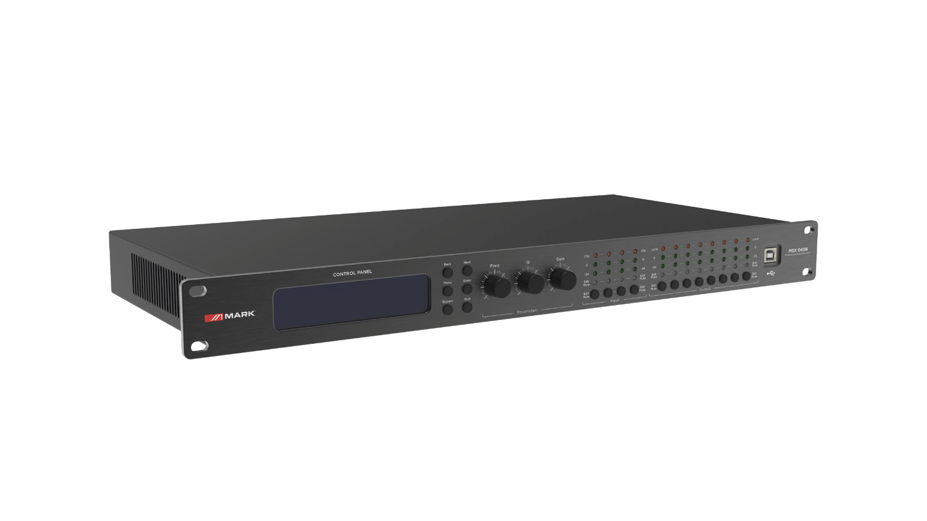

SAFETY INSTRUCTIONS
1. Read the instructions of this manual.
2. Keep these instructions in a safety place.
3. Heed and follow all warnings and instructions.
4. Please, respect your country safety regulations.
5. Don’t use this device close to the water or high humidity places. Clean only with dry cloth.
6. Don’t install near any heat sources such as radiators, heat registers, stoves, or other apparatus that produce heat. Make certain that the equipment is always installed so that is cooled and can’t overheat.
7. Don’t block any ventilation openings. Install in accordance with the manufacturer’s instructions.
8. Protect the power cord from being walked on or pinched, particularly at plugs, convenience receptacles, and the point where they exit from the apparatus.
9. Only use attachments/accessories specified by MARK PRO.
10. Unplug this device during lightning storms or when unused for long periods of time.
11. The technical service is required when the device has been damaged in any way, such as power supply cord or plug is damaged, liquid has been spilled or objects have fallen into the device, doesn’t operate normally or has been dropped.
12. To completely disconnect this apparatus from the AC mains, disconnect the power supply cord plug from the AC receptacle.
13. The mains plug of the power supply cord shall remain readily operable.
14. WARNING – to reduce the risk of fire or electric shock, don’t expose this device to rain or humidity.
15. Don’t expose this equipment to dripping or splashing and ensure that no objects filled with liquids, such as vases, are placed on the equipment.

OVERVIEW
MDX 0408 is a professional audio processors that can realize a variety of DSP functions. It integrates compressors, limiters, frequency dividers, dynamic EQ, delayers, equalizers, input and output with FIR phase correction, and audio mixers. The matrix can be quickly debugged and monitored through the beautiful and intuitive software, which provides a broad operating space for the construction and operation of professional audio amplification systems. MDX 0408 can manage 4 inputs to 8 outputs.
The MDX 0408's applications make it ideal for managing the audio of venues such as stadiums, professional performance, auditoriums, multifunctional halls, conference systems, etc.

Technical Data:
Specifications | MDX 0408
Signal processor | ADI SHARC 21489
Audio system delay | 1.8 ms
D/A conversion | 24-bit
Sampling rate | 96 kHz
Input channel | 4 balanced inputs, Line level, XLR3
Input resistance | 11 kΩ
Maximum input level | 16 dBu/Line
Output channel | 8 balanced outputs, Line level, XLR3
Output impedance | 100 Ω
Frequency response curve | 20 Hz – 40 kHz (±0.5 dB)/Line
Noise Floor | 20 Hz – 20 kHz, A-wt, -93 dBu
THD+N | -90 dB @ 0 dBu, 1 kHz, A-wt/Line
SNR | 108 dB @ 16 dBu, 1 kHz, A-wt/Line
USB | Type B
RS232 | Serial port communication D-SUB9
TCP/IP network port | RJ-45
Indicator light | CLIP, LEVEL EDIT, MUTE
Power supply range | AC 90/264 V 50/60 Hz
Dimmensions | 483 mm x 215 mm x 44.5 mm
Weight | 3.2 Kg

Features
- Control via Ethernet, USB and RS232.
- DSP 24 bit.
- 96 kHz / 24 bit sampling (*FIR @ 48 kHz).
- Software control MarkDSP.

CONTROLS & FUNCTIONS

FRONT PANEL
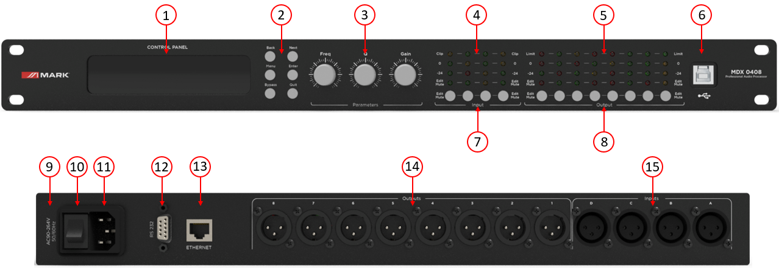
BACK PANEL

- LCD DISPLAY.
- BACK, NEXT, MENU, ENTER, BYPASS and EXIT.
- FREQ, Q and GAIN parameters.
- CLIP LEDs, 0 dB Input Level, -24 dB Input Level, Input EDIT and MUTE LEDs.
- LIMIT LEDs, 0 dB Input Level, -24 dB Input Level, Input EDIT and MUTE LEDs.
- USB-B interface.
- Input long press: EDIT, input short press: MUTE.
- Output long press: EDIT, output short press: MUTE.
- FUSE box.
- POWER Switch.
- POWER plug IEC C14.
- RS232 port.
- Ethernet port.
- 8 channels Balanced OUTPUTS XLR3.
- 4 channels Balanced INPUTS XLR3.

DISPLAY FUNCTION

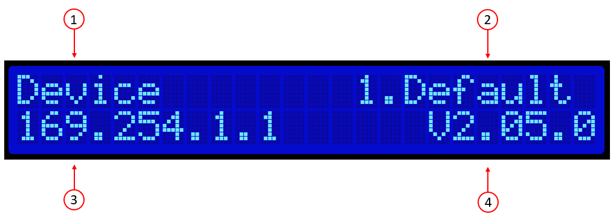
- Device name: The user can customize and modify the name throught the control software or the lower computer.
- Current gear: The preset currently applied by the device.
- Device IP: When the device is connected to the software via TCP/IP, the device and the computer must be in the same IP domain, for example, the device IP is 169.254.xxx.xxx, and the computer IP should be 169.254.xxx.xxx.
- Device firmware version: display the firmware version burned by the device.

①Press MENU, it will show menu list, using NEXT or BACK to select functions: GLOBAL MEMORY, INPUT SECTION, MATRIX, SYSTEM, press QUIT to exit.
Functions in panel | Menu list | Remark
1.GLOBAL MEMORY | RECALL a Memory  STORY a Memory  DELETE a Memory
2.INPUT SECTION | A ANALOG  B ANALOG  C ANALOG  D ANALOG
3.MATRIX | Routing Out.1=Input A*.... | Long press such output channel button under LED to change.
4.SYSTEM | 1 IP SET  2 RENAME  3 DSP VERSION

②Press BYPASS, it will quickly show RECALL a Memory function, using NEXT or BACK to select presets and then press ENTER to enable one of presets.

INPUT SECTION
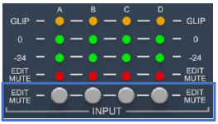
EDIT/MUTE button (mute and edit button):
Long press [EDIT/MUTE key] EDIT/MUTE light turns on blue light, enters the channel menu editing mode, lights up multiple channels at the same time, enters the channel joint edit mode, click other input channels at this time, there will be more than two channels lighted blue at the same time Light, indicating joint adjustment of channel functions
Short press [EDIT/MUTE key] The EDIT/MUTE indicator lights up in red, and the channel is muted; the EDIT/MUTE indicator lights up in purple when the edit mode and mute are turned on at the same time
Use [BACK] and [NEXT] Keys to switch functions and parameter editing

OUTPUT SECTION
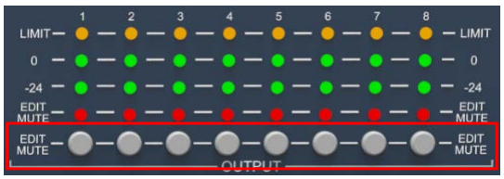
EDIT/MUTE button (mute and edit button): Refer to the input section for function editing and operation mode.

INTRODUCTION TO PC SOFTWARE AND OPERATING

Software provides users quickly interact with all the parameters of one or more machines. It can store the configuration parameters of the machine in the machine and the computer, providing a very convenient way to preset scenes and parameters for different systems. The software has high execution efficiency and clear interface structure.
The software is suitable for WIN7/WIN8/WIN10 x86/x64 operating system with Microsoft .NET Framework 4.0 runtime.
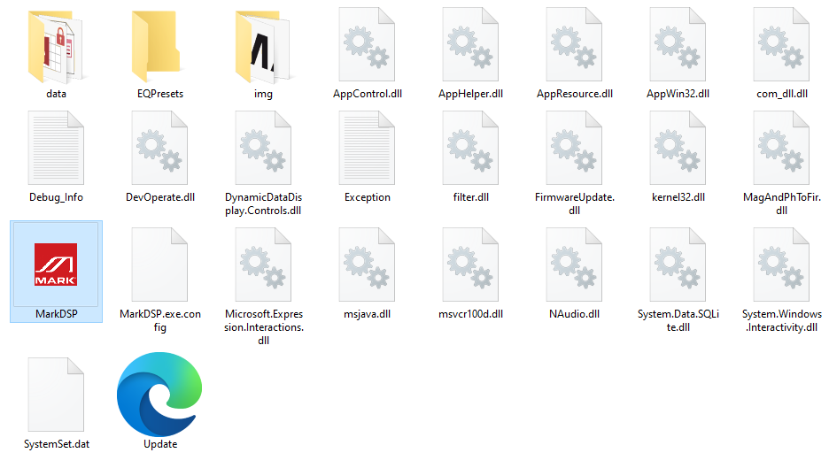
This software is a green version and does not require installation. The folder contains the following files or folders, all of which are indispensable. The green version of the software does not include the Microsoft .NET Framework 4.0 runtime. If necessary, please download and install it from the official Microsoft website.
Double-click the executable file in the folder 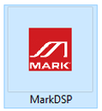, enter the main interface of the software.
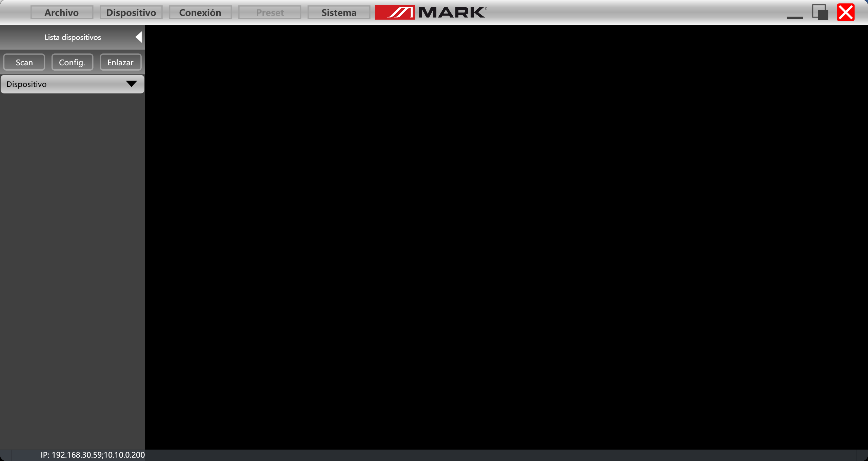
Please keep only one software open for each computer!

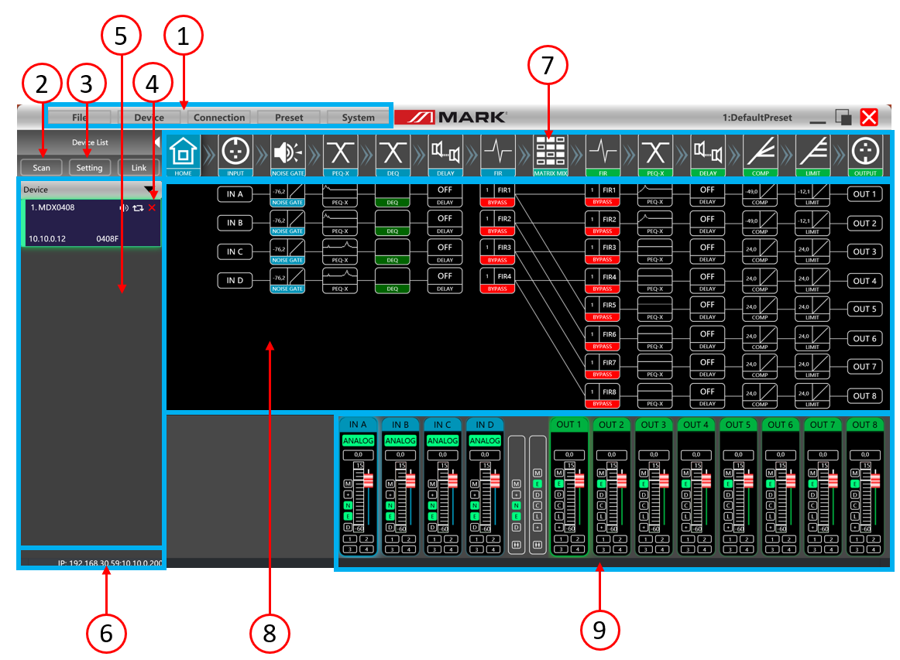
1. Menu bar
2. Scan button
3. Setting button
4. Joint debugging buttons
5. Equipment list
6. Computer IP address
7. Function control keys
8. Function status interface
9. Volume monitoring of input and output channels

Monitoring and setting channels:
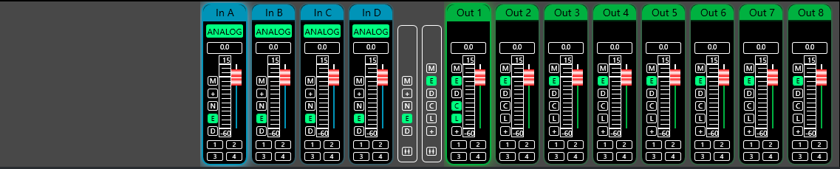
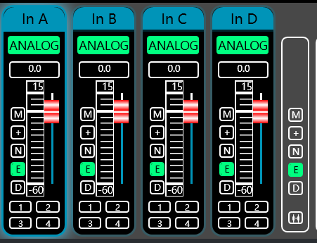
There are 2 kinds of input signal in device: ANALOG and testing signal. It will show a label for user.
Input value, drag gain fader or use mouse pulley to set value of gain.
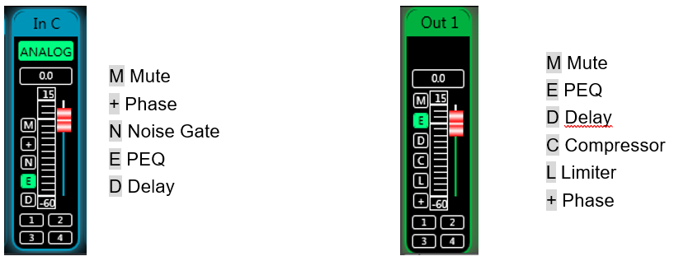
Group and channel link:
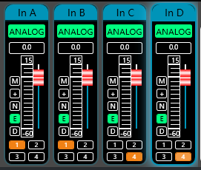
User can quickly set channels in groups for opening or closing mute, phase, noise gate, PEQ and delay function.

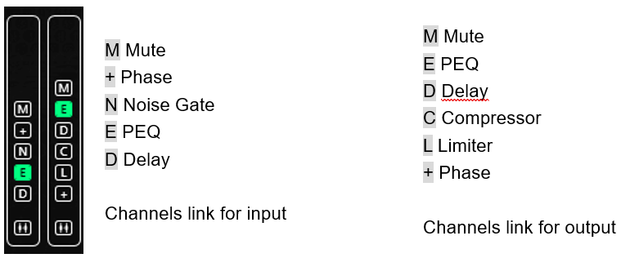

MENU BAR
File:
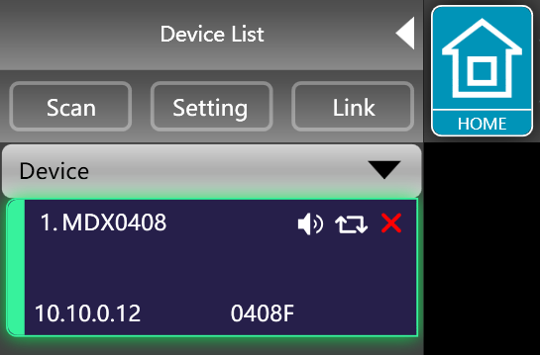
1. New, new project, the project is restored to the initial open state.
2. Add new devices, add virtual devices, you can view all the functions of the device without affecting the specific device connected.
3. Open, it opens an existing device management project from the computer disk.
4. Save, it saves the current equipment management project in the computer disk.
5. Save as, it saves as the current equipment management project to the computer disk.

Device:
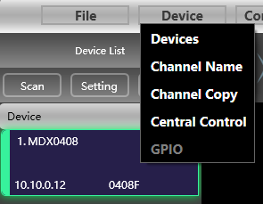
Devices: view or modify the software version information, device name and device IP address of the upper and lower computer of the device.
Channel name: set the name of each input and output channel, with memory function.
Channel copy: copy device input and output channel parameters, can realize cross-device copy parameters.
Central control: read or write Hexa scene commands. Both write and read through the RS-323 and TPC port
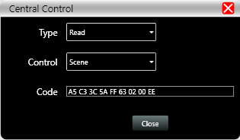
Connection:
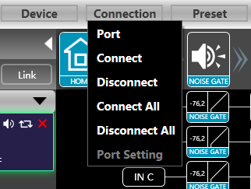
Port: set the connection mode, port number and baud rate, confirm the connection mode and then select the corresponding port.
Connect : connect and download the device parameters.
Disconnect: disconnect the connected device.
Connect all: connect and download the device parameters of all devices in the device list.
Disconnect all: disconnect all connected devices in the device list.

Preset:
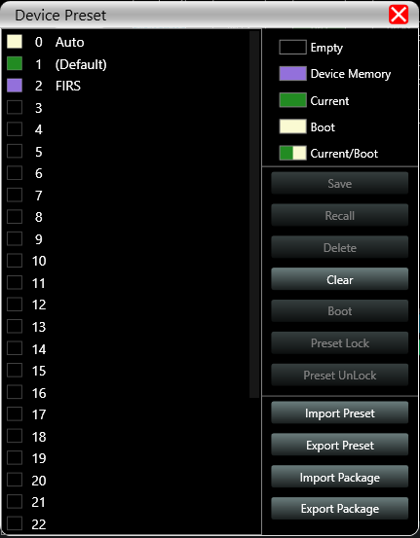
Save: select the saved gear, save all the parameters of the current automatic gear of the machine to the device preset (2~30 Preset bit).
Call: call the device preset to the current automatic gear position.
Delete: delete the existing preset, the default file cannot be deleted, over written or saved.
Clear: delete all presets in the device.
Set as the boot file: select a certain preset, after setting it as the boot file, each time the device is powered on, it will automatically call the save the parameters; the last set parameters need to be automatically saved, please set the Page 12 / 34 automatic file to the boot file.
Preset lock: lock the saved archive and set the password.
Preset unlock: Enter the password to unlock the saved archive.
Import preset: import a single preset file on the computer.
Export the preset: export all the parameters of the current state to the computer, and generate a single preset file.
Import preset package: import the preset package file containing multiple presets on the computer.
Export preset package: pack multiple presets in the machine’s preset into one preset package and export it to the computer.

System:
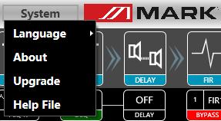
Language: multi- language switching, supports SPANISH, and ENGLISH.
About: the current host computer software and device firmware version information.
Upgrade: call the upgrade applet to upgrade the firmware of the device.

Scan button:
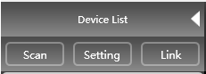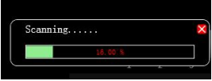
Click the "Scan" button and directly scan all devices in the current connection mode and display the scanning progress.

Set button:
Select the corresponding device connection port and click the "Settings" button, and the port connection interface as shown will pop up. Select the corresponding port and confirm after setting the parameters. If the device port changes, click the "Refresh" button in the lower left corner for instant Update port information.

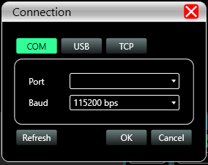

Link button:
To set the parameters of multiple devices at the same time, click the "Link" button, and the following figure Device networking link interface will pop up. Select the device of the same model in the left frame, move to the group in the middle frame, and then select the synchronization settings required After pressing the "OK" button, the grouping is successful. You can also use the same operation to modify the network grouping settings.

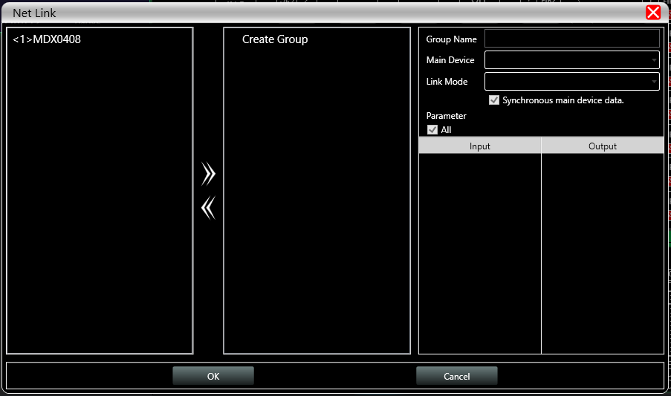

Device list:
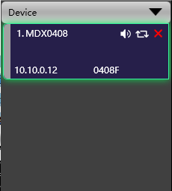
When a device is scanned or manually added, the corresponding device will be automatically added to the device list, and the user can operate on the target device, or operate multiple devices in groups at the same time.

Computer IP address:

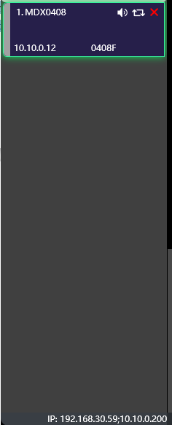
When the software is opened, it will automatically obtain the IP address of the computer system that the device is connected to. If there are 2 IP addresses, the first one is the IP address of the wireless network card by default, and the second is the IP address of the wired network card. If the device appears If the IP address and the computer IP address are inconsistent, right- click the device to modify the device IP, or modify the computer IP address to ensure that the IP of the device and the computer are in the same network segment.

Function control keys:
Open or close the related function interface and positioning module interface of the device. Double-click to open/close, and click to locate.

Function module interface:
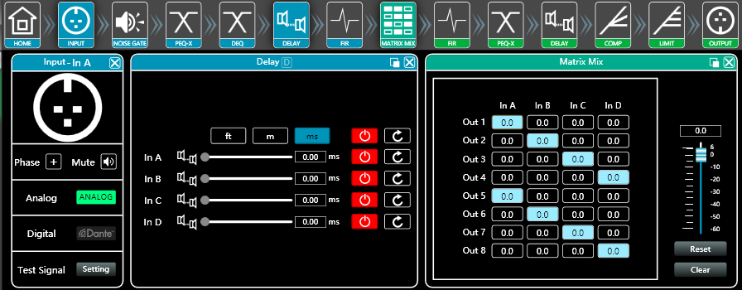
Each function module is opened and closed by the control key, and the function page and detailed parameters are displayed, and detailed settings can be made, and single or multiple functions can be operated freely. You can drag the function name position left and right to switch different function pages.

Input and output channel volume monitoring:
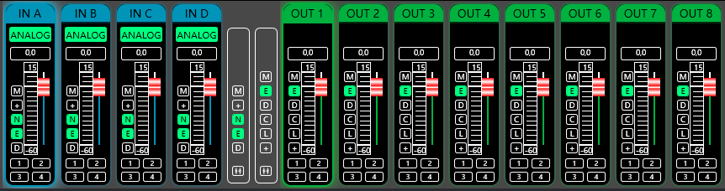
It can display the level, gain, input mode, channel name and other information of each channel, control the corresponding channel gain, DSP function master switch, and turn on the input and output channel grouping joint adjustment function to achieve more flexible and practical operability.

Main interface of input function:
Double-click in the function button 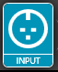, and the input function interface as shown in the next figure.
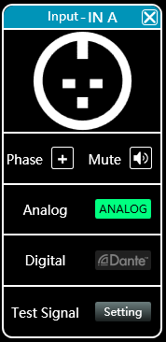
The phase polarity, mute, and input modes of the corresponding input channels can be operated; in the input mode, analog input, digital input (unavailable), and test signal can be selected from one of three, and a channel can only have one input mode.

Test signal function:
Click the "Settings" button on the right side of "Test Signal" to pop up the test signal interface.
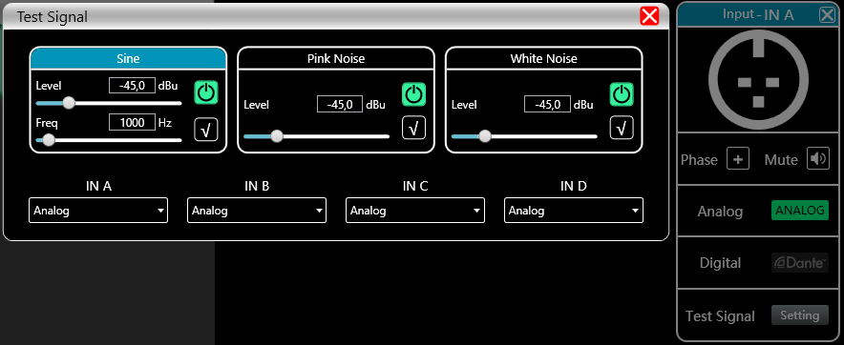

It is divided into the upper half of the test signal switch setting options and the lower half of the channel selection test signal options. Configure the three commonly used test signals (sine wave, pink noise, white noise) to set the switch and gain value, green is open, red is closed. For channel selection, if you select "sine wave", "pink noise" and "white noise", the open test signal will enter the channel; if it is selected as an analog signal, it will switch back to analog signal input and turn off the test signal.

Input noise gate:
Double-click in the function button , the following figure input noise gate function interface will pop up.
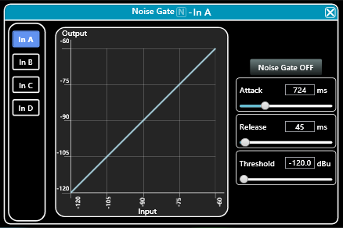
As shown in the figure above, click the noise gate switch in the upper right corner on and the red is off. The attack time, release time, and threshold level are the parameters corresponding to the noise gate function. You may drag the slider 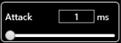 or block values corresponding to the input numerical values .
When the noise gate function is turned on, the points in the graph on the left 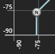 can be dragged diagonally to adjust Page 18 / 34 the value of the start control level.

Input Parametric Equalizer:
Double-click in the function button  to pop up the parameter equalizer page. The button in the upper right corner of the module can enlarge this interface for easier debugging.
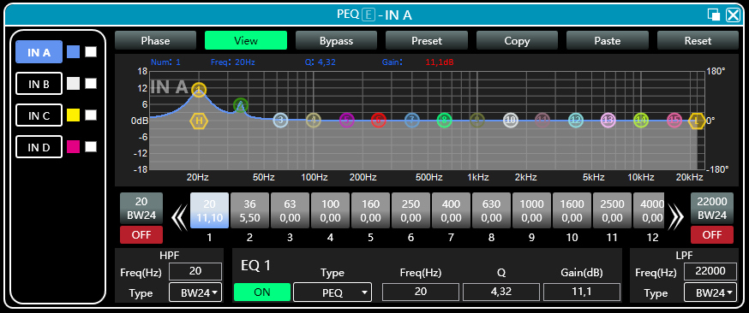

Function buttons:
The functions of the top buttons are:
Phase curve: display the phase curve of the current channel.
View: show or hide all balance control points.
Bypass: turn on or off all equalizer EQ of the current channel at the same time.
Preset: save all the setting parameters of the equalizer of the current channel to the computer, and recall the channel equalizer parameters of the computer, which can be called across channels and devices. Copy: copy the current channel equalizer parameter value, which can be pasted to other similar channels (such as input channel parameters can only be copied to other input channels).
Paste: used in combination with the copy button to paste the last copied equalizer parameter value to the current channel.
Reset: reset the equalizer parameters to the default parameter values

Multi-channel EQ curve display
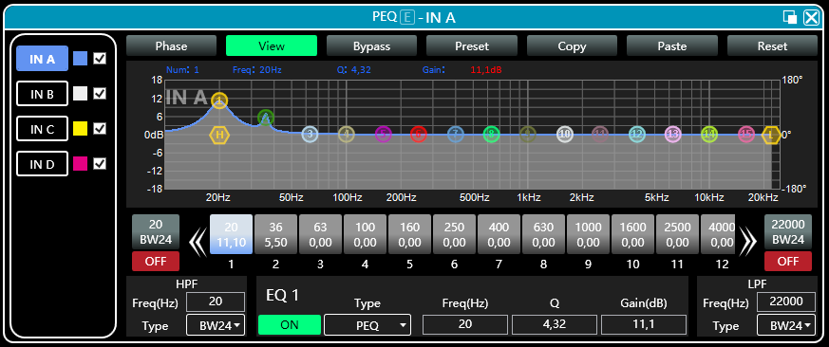
As shown in the figure above, the left side  is the interface switching button for each channel. Click to switch the EQ channel, and the color is the currently selected channel. is the curve color of the EQ channel. For each channel's EQ curve display switch, check it to enable it to display the curves of other channels in the current channel interface.

EQ curve chart:
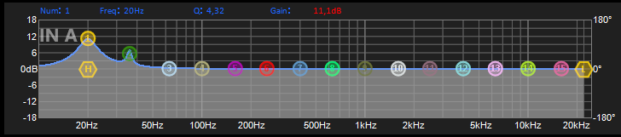
As shown in the figure above, it is used to control and display the current channel EQ curve. The corresponding multi-segment control points in the chart can be adjusted by clicking the left mouse button up, down, left, and right to adjust the EQ curve. Select the control point and press and hold the right mouse button to adjust the Q value.

EQ control parts:
Below the curve chart all the EQ control serial numbers and corresponding detailed values are displayed 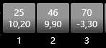, which can be used to locate the position of the control. Combined with the following EQ parameter adjustment items, the parameter value of each EQ can be precisely adjusted.

EQ parameter adjustment items:
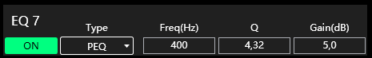
As shown in figure above, below the EQ control is the EQ parameter adjustment item, which can accurately control the EQ switch, type, frequency, Q value, gain and other parameters. Filter types include PEQ parametric equalization, LSLV/HSLV high and low shelf, and ALLPASS all- pass filter.

Preset button:
When you click the EQ Preset button, the following EQ Preset will pop up
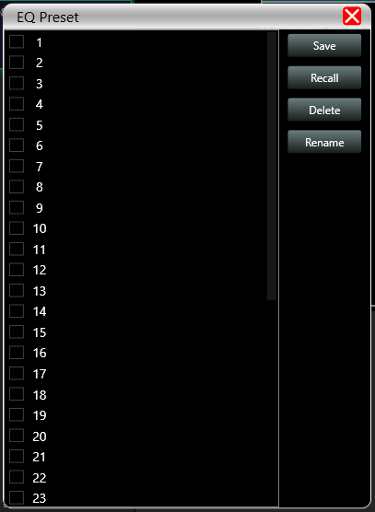
Select the preset item corresponding to the gear list on the left, and then click the function button on the right to realize the preset, recall, delete, and rename functions of the equalizer setting parameters. The preset parameters are saved to the computer in the designated folder in the software.

Dynamic EQ:
Double-click in the module button 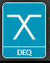, input delay function interface will pop up.
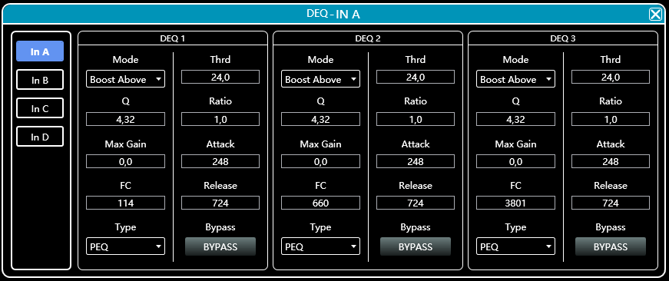
- Click the input button 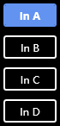 to switch the input channel.

- As shown in figure, 4 kinds of DEQ modes: Boost Above, Boost Below, Cut Above, Cut Below, Max Gain.
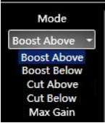

3. Click 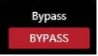to choose BYPASS type or PEQ type.
4. Threshold, Q value, Ratio, Max Gain, Attack, Frequency, and Release time for the DEQ corresponding parameters, which can be set by modifying the numeric box value.

Input delay:
Double-click in the module button 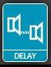, input delay function interface will pop up.
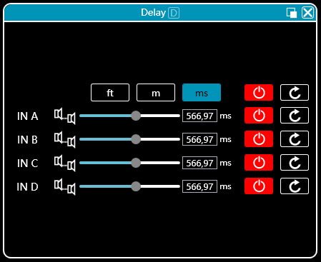
As shown above, the delay lists all input channels control content, drag the left slider can directly adjust the delay value corresponding to the channel, box or value corresponding to the input values, the right side of the switch delay function , Red is off, green is on, the reset button on the far right can directly reset the default value of the channel delay.

Input and output with FIR:
Double-click in the function button 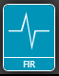, FIR function page will pop up. Upper right corner can zoom the interface.
When user uses PEQ to adjust audio signal and set a linear magnitude, he can find the phase of signal changed, due to IIR filter. However, DSP products provide user a useful tool FIR filter to adjust audio signal with a linear phase.

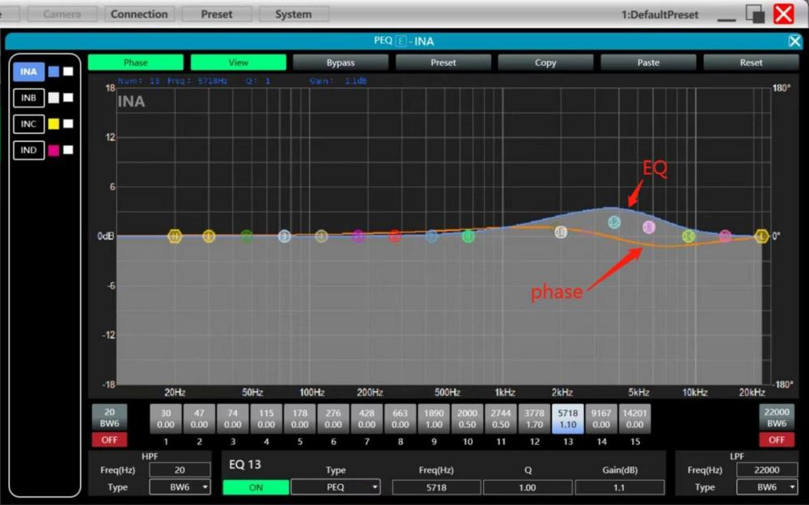
Some calculation:
Frequency resolution = Sampling/Taps
Available min. frequency ≈ Frequency resolution*3

Means when use adjust audio signal with 48kHz, 1024 taps, FIR filters will take effect in frequency above 141Hz of audio signal. The taps value more high, the FIR filter curve more steep.

FIR filter processing audio signal will produce a certain delay:
Delay = (1/Sampling Hz)*Taps/2
Taps  Sampling | 48kHz | 96kHz
256 | 2.67ms, LF 563Hz | 1.33ms, LF 1125Hz
512 | 5.33ms, LF 279Hz | 2.67ms, LF 558Hz
768 | 7.99ms, LF 188Hz | 4.00ms, LF 375Hz
1024 | 10.67ms, LF 141Hz | 5.33ms, LF 281Hz
2048 | 21.33ms, LF 70Hz | 10.67ms, LF 141Hz

*Outputs 7 and 8 do not support 512 taps

Applications:
Linear of the phase curve of the speaker;
Match the phase and magnitude of different speaker models within the same product line, as well as different speaker models in the installation project to make it easier to debug speaker groups and arrays;
Dealing with linear array systems (for audience area coverage optimization);
Frequency division optimization to improve the consistency of frequency response of multi-division speakers over their coverage Angle range.
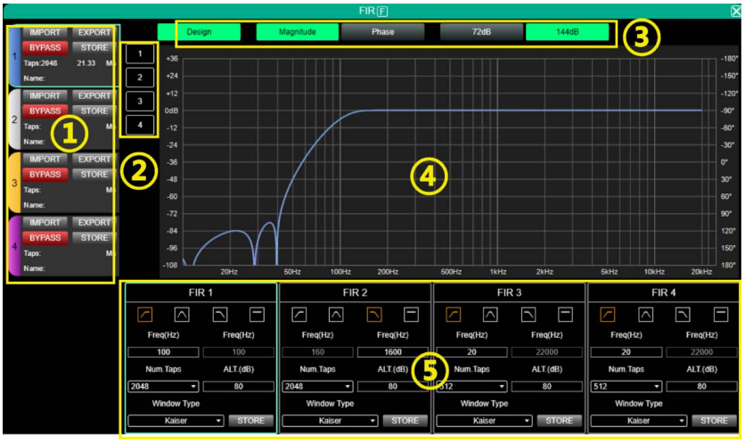
① Setting area:
IMPORT: import FIR preset file to current channel.
EXPORT: export FIR preset file of current channel.
BYPASS: EQ is straight after bypass available, red for open, turn off manually when using FIR.
STORE: store FIR parameters in the device.
Taps: current Taps quantity.
Ms: current delay.
Name: current name of FIR preset file.
② Channels select: click and show current channel with FIR curve, support multiple channels.
③ Parameters select:
Design: design switch button for interface.
Magnitude: show magnitude curve.
Phase: show phase curve.
72dB: show content accuracy within 72dB amplitude.
144dB: show content accuracy within 144dB amplitude.
④ Curve area:
- 108～ +36: amplitude accuracy, the value used for reference when the current display is an amplitude curve.
- 180°～ +180°: phase accuracy, the value used for reference when the current display is a phase curve.
20Hz～ 20kHz: bands.
⑤ Design area:
: high pass, frequency band, low pass, flat.
Freq(HZ): start frequency setting, high pass on the left, low pass on the right.
Num.Taps: taps, 8 steps in total. optional 256-2048.
ALT.(dB): depth, only available in Kaiser window.
Windows Type: window type selection.
STORE: click to save setting the parameters to the device channel.

Matrix Mixing:
Double-click in the function button 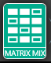,matrix mixing function page will pop up.
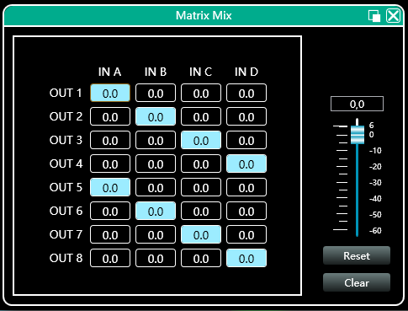
In the above figure, the left side corresponds to the output channel, and the upper side corresponds to the input channel. The value box with a value is the input and output channel mixing key. When the mixing key is green (double- click the value box to switch the state), the input channel and output channel signal realizes the mixing function. The right part of the above figure contains the gain, reset button, and clear button of the matrix mix. Click the value box on the left, and then drag the sliding block of the matrix mix gain or enter a value in the value box to adjust the matrix block Click the reset button to reset the matrix mixing function to the initial one- to- one state; click the clear button to clear all the matrix mixing functions, and there is no correspondence between the input and output of the device.

Output Parametric Equalizer (PEQ):
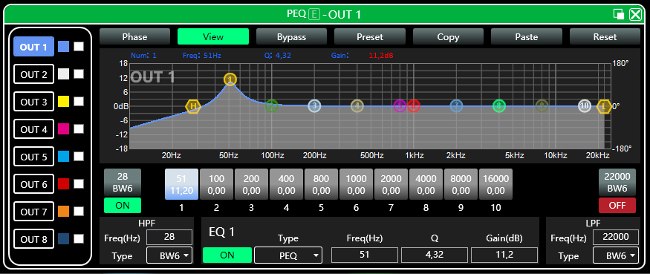
Double-click the function button 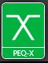, output equalizer function interface will pop-up shown, the parameter equalization function and operation mode are the same as input equalizer. But the output has increased the high and low pass filter function than the input, as described below.

EQ high and low pass filter:
As shown above, high pass or low pass section in the lower right corner as shown in the left 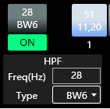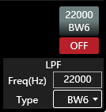, you can control the switch, frequency and type of high pass and low pass , highest filter type slope is 48dB
Output delay:
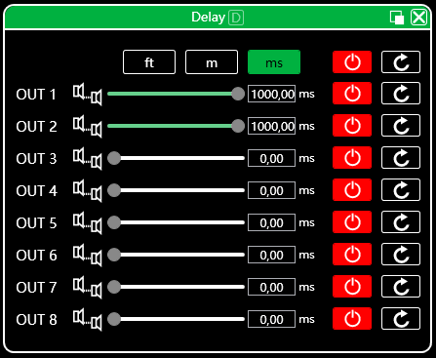
Double-click in the function button 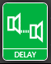, and the output delay function interface will pop up. The function and operation method are the same as input delay.

Output compressor:
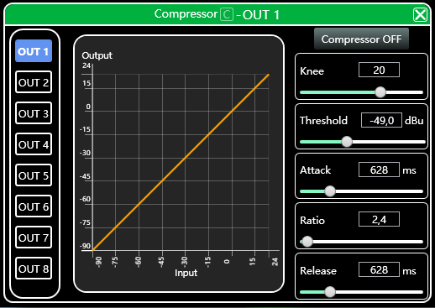
Double-click in the function button , output compressor function interface pops up.
Output limiter:
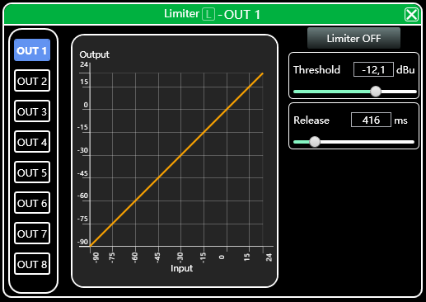
Double-click in the module button ,output limiter setting module will pop up.

Output module:
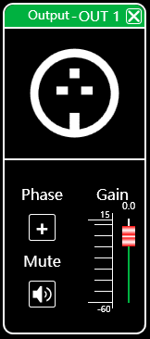
Double-click in the module button , and the output setting module will pop up.
As shown in the figure above, you can control the polarity, mute, and gain settings of the corresponding output channel.

Input and output channel volume monitoring:
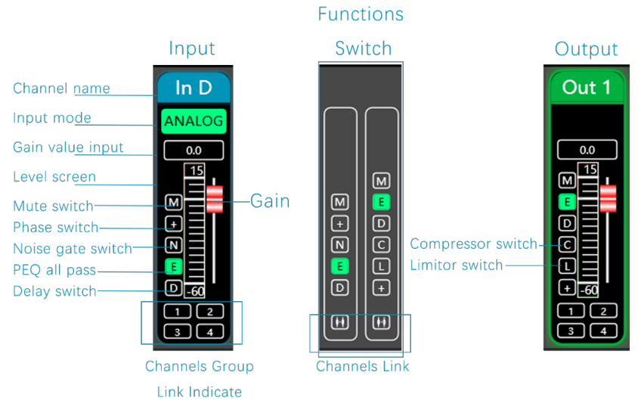

Channel links:
Click the channels link button  between the input and output channels on the software homepage, channels link interface will pop up as following figure.
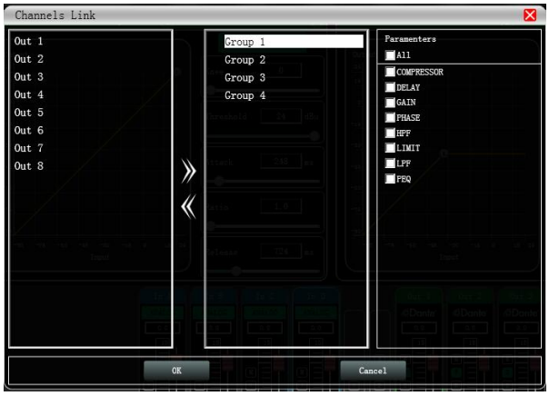
As shown in the figure above, the three lists from left to right are divided into channel list, group list, and parameter list: The channel list has listed all the channels that can be tuned together. After selecting the corresponding channel, click the Add button to move to the group list. After grouping the list of default four groups, directly select the corresponding packet, if the channel list will be added directly to the channel assigned to the selected group, to remove the optional channel to be removed by clicking the Remove button  below to add a button that is can be removed to the channel list. The parameter list is the parameters that can be adjusted jointly in the grouping list. When the check is ticked, it means that when the parameters of several channels in the same group are adjusted, other channels will make the same adjustment at the same time.
Device list:
The device list on the software homepage.
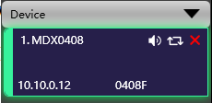
The above figure (1.) shows the connected device numbers, which are automatically arranged in the order they are scanned; (1.MDX0408) is the device name, which can be changed at will, which is convenient for management; (0408F) is the factory name (the user cannot modify it); if the connection method is TCP, the factory name will be left after the connection is connected. The side will display the IP address of the device; if it is in USB mode, it will display USB; if it is connected in serial port mode, it will display the specific COM port used. From left to right, it is divided into mute button, disconnect/connect button, and remove device button. The mute button can directly control the mute of all output channels of the entire device. If the device is online, the leftmost position will turn green . The remove button can be used to remove the device directly in the software. If you need to debug different devices, you can click to select the target device, and the function interface will switch to the device function page.

Add device:
Click "File"- "New Device" in the menu bar of the main software interface, and the following Add Device Interface will pop up. Select the virtual device model to be added and add it to the device list. Note: The virtual device will not connect to the real device.
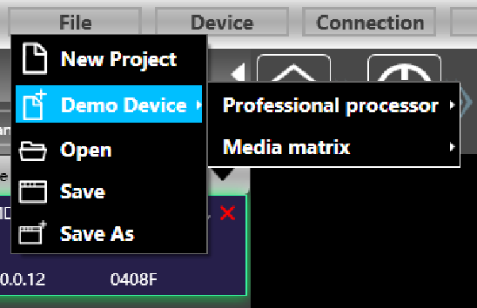

Device Management:
Click "Device"- "Device " in the menu bar of the main software interface, and the device management interface will pop up.
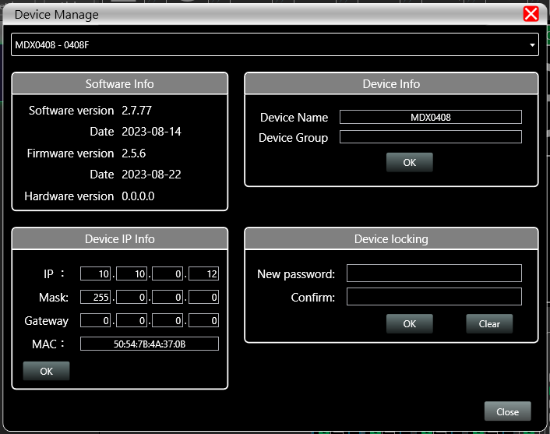
As shown in the figure above, the device information content displayed on the target device management interface can be selected in the device list at the top. The device management interface is divided into three parts as follows:
Software information: display the current device's upper and lower computer version number and date information.
Device information: display the current device name and device grouping, among which "device name" can be entered in the new name and then click the button to save.
Device IP information: If the current device is connected with network information, the IP address, gateway, and MAC address of the device will be displayed here. The IP and gateway can be modified and click the OK button to save and restart the device network module, which newly entered network information will take effect immediately.

Channel name management:
Click "Device"- "Channels Names" in the menu bar of the main software interface, and the Channel Name interface will pop up.
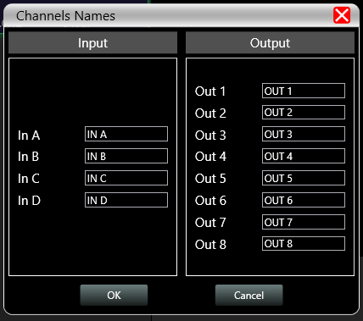
As shown in the figure above, after entering the new name of the channel in the corresponding channel, click the OK button to save and update the name of the channel immediately. Note that the length of the channel name is limited to 5 English letters and numbers.

Channels copy:
Click "Device"- "Channels Copy" in the menu bar of the main software interface, and Channels Copy interface will pop up.
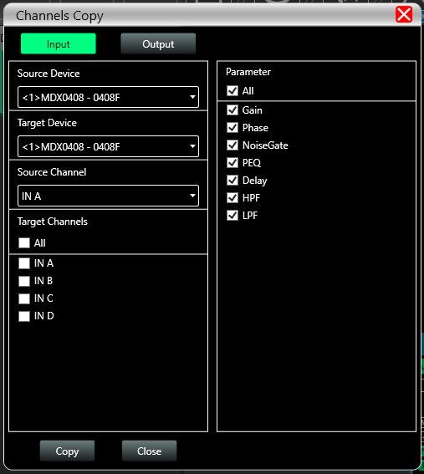
As shown in the figure above, channel copy is to first select the source channel parameters of a source device and copy them to the target channel of the same device or other target devices. Input channels and output channels cannot copy each other. The left side is the corresponding channel, and the right side is the parameter to be copied. The "input" and "output" buttons at the top of the interface can switch the channel type for copying.

Device preset:
Click "Preset" in the menu bar of the main interface of the software, and the device preset interface will pop up.
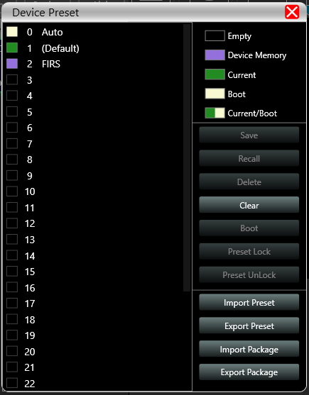
As shown in the above picture, the left side of the preset interface is the gear position, among which "0 automatic gear" is the system gear position, which automatically saves all parameters; "1 (default)" is the default file of the device, which can only be recalled, and cannot be deleted or overwritten. The parameters will all be restored to the factory default parameters; other gears can be freely saved, recalled, deleted and other operations.
The function buttons on the right side of the preset interface are as follow:
Save: Save the existing device parameters to the corresponding selected preset.
Recall: Recall the selected preset to the current parameters of the device.
Delete: delete the selected preset parameter.
Clear: Clear all preset parameter records that are not preset by the system.
Set as boot file: Set the selected gear as the boot file, and each time the power is turned on, the boot file will be automatically called and all the parameters of the preset will be automatically used to work.
Import and preset: Import a single device parameter file in the computer system, and directly overwrite the existing parameter data.
Export and preset: save the current equipment parameters to the computer system to produce a single equipment parameter preset file.
Import preset package: import multiple preset parameter packages in the computer system.
Export preset package: Export the parameters of all gears in the equipment preset to the computer system to produce multiple preset parameter package files.

Firmware upgrade:
Click "System"- " Upgrade" in the menu bar of the main software interface, and the firmware upgrade interface will pop up.
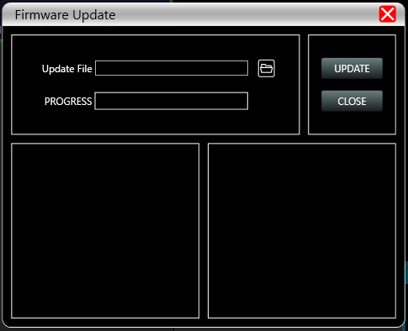
When the lower computer system of the device has been updated, after obtaining the upgrade file, you can open the firmware upgrade interface as shown in the figure above. After selecting the corresponding upgrade file in the "Upgrade File" column, click "UPGRADE" in the upper right corner, and the system will automatically start upgrade operation as well as transfer upgrade file to the lower device, and the operation log is displayed in the progress box below. After the upgrade is completed, the machine will restart automatically or manually restart the machine to complete the upgrade.

Dimmensions:
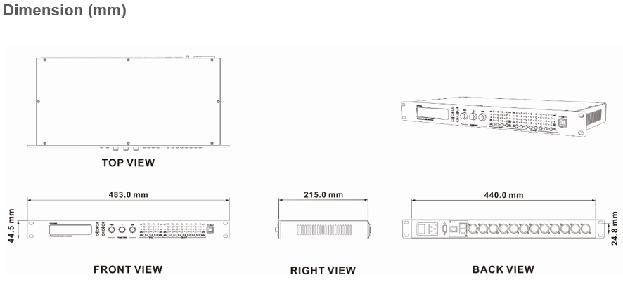

TROUBLESHOOTING
This short guide is meant to help and try to solve simple problems. If they continue and the device cannot operate, please, don’t try to repair it by yourself, return the device to your MARK PRO dealer.
If a problem occurs, carry out the following steps in sequence until find the problem solved.
- If the device does not operate properly, unplug the device.
- Check the fuse, power from the wall, all cable, etc.
- If all the above appears to be OK, plug the unit in again.
- If you are unable to determine the cause of the problem, do not open the device, as this may damage the unit and the warranty will become void.
- Return the device to your MARK dealer.

INSTRUCCIONES DE SEGURIDAD
1. Lea las instrucciones de este manual.
2. Guarde estas instrucciones en un lugar seguro.
3. Preste atención y siga todas las advertencias e instrucciones.
4. Por favor, respete las normas de seguridad de su país.
5. No utilice este aparato cerca del agua o en lugares con mucha humedad. Límpielo sólo con un paño seco.
6. No lo instale cerca de fuentes de calor como radiadores, rejillas de calefacción, estufas u otros aparatos que produzcan calor. Asegúrese de que el equipo esté siempre instalado de forma que esté refrigerado y no pueda sobrecalentarse.
7. No bloquee ninguna abertura de ventilación. Instale de acuerdo con las instrucciones del fabricante.
8. Proteja el cable de alimentación para evitar que sea pisado o pellizcado, especialmente en los enchufes, tomas de corriente y en el punto donde salen del aparato.
9. Utilice únicamente los accesorios especificados por MARK PRO.
10. Desenchufe este aparato durante tormentas eléctricas o cuando no lo vaya a utilizar durante largos periodos de tiempo.
11. la intervención del servicio técnico será necesaria cuando el aparato haya sufrido algún tipo de daño, como que el cable de alimentación o el enchufe estén dañados, se haya derramado líquido o hayan caído objetos dentro del aparato, no funcione con normalidad o se haya caído.
12. Para desconectar completamente este aparato de la red eléctrica de CA, desconecte el enchufe del cable de alimentación del receptáculo de CA.
13. La clavija de red del cable de alimentación deberá permanecer fácilmente operable.
14. ADVERTENCIA - para reducir el riesgo de incendio o descarga eléctrica, no exponga este aparato a la lluvia ni a la humedad.
15. No exponga este aparato a goteos o salpicaduras y asegúrese de que no se coloquen sobre él objetos que contengan líquidos, como jarrones.

DESCRIPCIÓN
MDX 0408 es un procesador de audio profesional que puede realizar una gran variedad de funciones DSP. Integra compresores, limitadores, divisores de frecuencia, EQ dinámica, retardadores, ecualizadores, entrada y salida con corrección de fase FIR y mezcladores de audio. La matriz se puede depurar y supervisar rápidamente a través del intuitivo software, que proporciona un amplio espacio operativo para la construcción y el funcionamiento de sistemas profesionales de amplificación de audio. MDX 0408 puede gestionar de 4 entradas a 8 salidas.
Las aplicaciones de la MDX 0408 la hacen ideal para gestionar el audio de recintos como estadios, espectáculos profesionales, auditorios, salas multifuncionales, sistemas de conferencias, etc.

Datos Técnicos:
Specifications | MDX 0408
Procesador de señal | ADI SHARC 21489
Retardo del sistema de audio | 1.8 ms
Conversión D/A | 24-bit
Frecuencia de muestreo | 96 kHz
Canal de entrada | 4 entradas balanceadas, nivel de línea, XLR3
Resistencia de entrada | 11 kΩ
Nivel máximo de entrada | 16 dBu/Línea
Canal de salida | 8 salidas balanceadas, nivel de línea, XLR3
Impedancia de salida | 100 Ω
Curva de respuesta en frecuencia | 20 Hz – 40 kHz (±0.5 dB)/Línea
Suelo de ruido | 20 Hz – 20 kHz, A-wt, -93 dBu
THD+N | -90 dB @ 0 dBu, 1 kHz, A-wt/ Línea
SNR | 108 dB @ 16 dBu, 1 kHz, A-wt/ Línea
USB | Tipo B
RS232 | Puerto de comunicación de Serie D-SUB9
Puerto de red TCP/IP | RJ-45
Indicador luminoso | CLIP, LEVEL EDIT, MUTE
Rango de alimentación | AC 90/264 V 50/60 Hz
Dimensiones | 483 mm x 215 mm x 44.5 mm
Peso | 3.2 Kg

Features
- Control via Ethernet, USB and RS232.
- DSP 24 bit.
- 96 kHz / 24 bit sampling (*FIR @ 48 kHz).
- Software control MarkDSP.

CONTROLES Y FUNCIONES

PANEL FRONTAL
PANEL TRASERO

1. PANTALLA LCD
2. BACK, NEXT, MENU, ENTER, BYPASS y EXIT.
3. Parámetros FREQ, Q y GAIN.
4. LEDs CLIP, 0 dB Nivel de Entrada, -24 dB Nivel de Entrada, Input EDIT y MUTE.
5. 5. LEDs LIMIT, 0 dB Input Level, -24 dB Nivel de entrada, Input EDIT y MUTE.
6. Interfaz USB-B.
7. Entrada pulsación larga: EDIT, pulsación corta de entrada: MUTE.
8. Salida pulsación larga: EDITAR, pulsación corta salida: MUTE.
9. Caja de fusibles.
10. Interruptor POWER.
11. Enchufe de alimentación IEC C14.
12. Puerto RS232.
13. Puerto Ethernet.
14. 8 canales de SALIDAS balanceadas XLR3.
15. 4 canales de ENTRADAS balanceadas XLR3.

FUNCIONAMIENTO DEL DISPLAY

1. Nombre del dispositivo: El usuario puede personalizar y modificar el nombre a través del software de control o del ordenador inferior.
2. Marcha actual: La preselección aplicada actualmente por el dispositivo.
3. IP del dispositivo: Cuando el dispositivo está conectado al software a través de TCP/IP, el dispositivo y el ordenador deben estar en el mismo dominio IP, por ejemplo, la IP del dispositivo es 169.254.xxx.xxx, y la IP del ordenador debe ser 169.254.xxx.xxx.
4. Versión de firmware del dispositivo: muestra la versión de firmware grabada por el dispositivo.

①Presione MENU, se mostrará la lista de menú, use NEXT o BACK para seleccionar las funciones: GLOBAL MEMORY, INPUT SECTION, MATRIX, SYSTEM, presione QUIT para salir.
Funciones en el DISPLAY | Lista de MENU | Observaciones
1.GLOBAL MEMORY | RECALL a Memory  STORY a Memory  DELETE a Memory
2.INPUT SECTION | A ANALOG  B ANALOG  C ANALOG  D ANALOG
3.MATRIX | Routing Out.1=Input A*.... | Mantenga pulsado el botón de canal de salida debajo del LED para cambiar.
4.SYSTEM | 1 IP SET  2 RENAME  3 DSP VERSION

②Presione BYPASS, esto mostrará la función RECALL a Memory, usando NEXT o BACK para seleccionar los presets, pulse ENTER para establecer uno de los presets.

SECCIÓN ENTRADA
Botón EDIT/MUTE (muteo y edición):
Pulsación larga [Tecla EDIT/MUTE] El indicador EDIT/MUTE se ilumina en azul, entra en el modo de edición del menú de canales, se iluminan varios canales al mismo tiempo, entra en el modo de edición conjunta de canales, haga clic en otros canales de entrada en este momento, habrá más de dos canales iluminados en azul al mismo tiempo Luz, indicando el ajuste conjunto de las funciones del canal.
Pulse brevemente [EDIT/MUTE key] El indicador EDIT/MUTE se ilumina en rojo, y el canal se silencia; el indicador EDIT/MUTE se ilumina en morado cuando el modo de edición y el silenciado se activan al mismo tiempo.
Utilice las teclas [BACK] y [NEXT] para cambiar de función y editar parámetros.

SECCIÓN SALIDA
Botón EDIT/MUTE (botón de silenciamiento y edición): Consulte la sección de entrada para la edición de funciones y el modo de funcionamiento.

INTRODUCCIÓN AL SOFTWARE Y AL FUNCIONAMIENTO DEL PC
Software provides users quickly interact with all the parameters of one or more machines. It can store the configuration parameters of the machine in the machine and the computer, providing a very convenient way to preset scenes and parameters for different systems. The software has high execution efficiency and clear interface structure.

The software is suitable for WIN7/WIN8/WIN10 x86/x64 operating system with Microsoft .NET Framework 4.0 runtime.
Este software es una versión ejecutable y no requiere instalación. La carpeta contiene los siguientes archivos o carpetas, todos ellos indispensables. La versión ejecutable del software no incluye el Microsoft .NET Framework 4.0 runtime. Si es necesario, descárguelo e instálelo desde el sitio web oficial de Microsoft. Haga doble clic en el archivo ejecutable de la carpeta y acceda a la interfaz principal del software.

Mantenga abierto sólo un programa por ordenador.

1. Barra de menú
2. Botón Scan
3. Botón de Settings
4. Botón de debug
5. Lista de equipos
6. Dirección IP del ordenador
7. Teclas de control de funciones
8. Interfaz de estado de las funciones
9. Control del volumen de los canales de entrada y salida

Supervisión y ajuste de canales:
Hay 2 tipos de señal de entrada en el dispositivo: ANALÓGICA y señal de TEST. Mostrará una etiqueta para el usuario.
Valor de entrada, arrastre el fader de ganancia o utilice la rueda del ratón para ajustar el valor de ganancia.
Linkado de Grupos y Canales
El usuario puede configurar rápidamente los canales en grupos para abrir o cerrar la función de silencio, fase, puerta de ruido, PEQ y retardo.

BARRA MENÚ
File:
1. NEW, proyecto nuevo, el proyecto se restablece al estado inicial abierto.
2. ADD NEW DEVIDES, añadir nuevos dispositivos, añadir dispositivos virtuales, puede ver todas las funciones del dispositivo sin afectar al dispositivo específico conectado.
3. OPEN, abre un proyecto de gestión de dispositivos existente desde el disco del ordenador.
4. SAVE, guarda el proyecto de gestión de equipos actual en el ordenador.
5. SAVE AS, “guarda como” el proyecto de gestión de equipos actual en el ordenador.

Dispositivos: ver o modificar la información de la versión de software, el nombre del dispositivo y la dirección IP del ordenador superior e inferior del dispositivo.
Nombre de canal: establece el nombre de cada canal de entrada y salida, con función de memoria.
Copia de canal: copia los parámetros de los canales de entrada y salida del dispositivo, puede realizar la copia de parámetros entre dispositivos.
Control central: leer o escribir comandos de escenas Hexa. Tanto de escritura como de lectura a través de los puertos RS-323 y TPC .
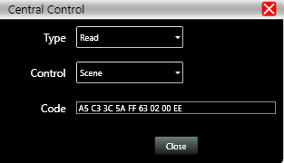

Conexión:
Puerto: establezca el modo de conexión, el número de puerto y la velocidad en baudios, confirme el modo de conexión y, a continuación, seleccione el puerto correspondiente.
Conectar : conectar y descargar los parámetros del dispositivo.
Desconectar: desconecta el dispositivo conectado.
Conectar todos: conecta y descarga los parámetros de todos los dispositivos de la lista de dispositivos.
Desconectar todos: desconecta todos los dispositivos conectados en la lista de dispositivos.

Preset:
Guardar: seleccione el equipo guardado, guarde todos los parámetros del equipo actual de forma automática en el preset del dispositivo (2~30 bit de preset).
Llamar: llamar el preset del dispositivo a la posición actual automática del equipo.
Borrar: borra el preset existente, el archivo por defecto no puede ser borrado, sobreescrito o guardado.
Limpiar: borra todos los presets del dispositivo.
Establecer como archivo de arranque: seleccione un determinado preset, después de establecerlo como archivo de arranque, cada vez que el dispositivo se encienda, llamará automáticamente al guardar los parámetros; los últimos parámetros establecidos necesitan ser guardados automáticamente, por favor, establezca de forma automática el Page 12 / 34 como archivo de arranque.
Preset lock: bloquea el archivo guardado y establece la contraseña.
Desbloquear preset: Introduzca la contraseña para desbloquear el archivo guardado.
Importar preset: importar un archivo de preset en el ordenador.
Exportar preset: exporta todos los parámetros del estado actual al ordenador y genera un único archivo de preset.
Importar paquete de presets: importar el archivo de paquete de presets que contiene múltiples presets en el ordenador.
Exportar paquete de presets: empaqueta múltiples presets de la máquina en un paquete y lo exporta al ordenador.
System:
Idioma: multi-idioma, soporta ESPAÑOL e INGLÉS.
Acerca de: información sobre el software actual del ordenador y la versión del firmware del dispositivo.
Actualizar: llama al applet de actualización para actualizar el firmware del dispositivo.
Scan button:
Haga clic en el botón "Escanear" y escaneará directamente todos los dispositivos en el modo de conexión actual y mostrará el progreso del escaneo.

Botón "Configurar":
Seleccione el puerto de conexión del dispositivo correspondiente y haga clic en el botón "Configurar", y aparecerá la interfaz de conexión de puertos que se muestran. Seleccione el puerto correspondiente y confirme después de configurar los parámetros. Si el puerto del dispositivo cambia, haga clic en el botón "Actualizar" de la esquina inferior izquierda para actualizar al instante la información del puerto.

Botón de Link:
Para configurar los parámetros de varios dispositivos al mismo tiempo, pulse el botón "Link", y aparecerá la siguiente figura Interfaz de enlace de red de dispositivos. Seleccione el dispositivo del mismo modelo en el marco izquierdo, desplácese al grupo en el marco central y, a continuación, seleccione los ajustes de sincronización necesarios Tras pulsar el botón "Aceptar", la agrupación se habrá realizado correctamente. También puede utilizar la misma operación para modificar los ajustes de agrupación de red.

Lista de dispositivos:
Cuando se escanea un dispositivo o se añade manualmente, el dispositivo correspondiente se añade automáticamente a la lista de dispositivos, y el usuario puede trabajar en el dispositivo de destino, o manejar varios dispositivos en grupos al mismo tiempo.

Dirección IP del dispositivo:
Al abrir el software, obtendrá automáticamente la dirección IP del sistema informático al que está conectado el dispositivo. Si hay 2 direcciones IP, la primera es la dirección IP de la tarjeta de red inalámbrica por defecto, y la segunda es la dirección IP de la tarjeta de red cableada. Si el dispositivo aparece y si la dirección IP y la dirección IP del ordenador no coinciden, haga clic con el botón derecho del ratón en el dispositivo para modificar la IP del dispositivo, o modifique la dirección IP del ordenador para asegurarse de que la IP del dispositivo y la del ordenador se encuentran en el mismo rango de red.

Teclas de control de funciones
Abrir o cerrar la interfaz de funciones relacionadas y la interfaz del módulo de posicionamiento del dispositivo. Haga doble clic para abrir/cerrar y clic para seleccionar.

Interfaz del módulo de funciones:
Cada módulo de función se abre y se cierra mediante su tecla de control y se muestra la página de función y los parámetros detallados, se puede realizar ajustes detallados, y se pueden operar libremente funciones individuales o múltiples. Puede arrastrar la posición del nombre de la función a izquierda y derecha para cambiar entre diferentes páginas de funciones.

Monitorización del volumen de los canales de entrada y salida:
Puede mostrar el nivel, la ganancia, el modo de entrada, el nombre del canal y otra información de cada canal, controlar la ganancia del canal correspondiente, el interruptor principal de la función DSP y activar la función de ajuste conjunto de agrupación de canales de entrada y salida para lograr una operabilidad más flexible y práctica.

Interfaz principal de la función de entrada:

Haga doble clic en el botón de función , y la interfaz de la función de entrada como se muestra en la siguiente figura.

Se puede manejar la polaridad de fase, el muteo y los modos de entrada de los canales de entrada correspondientes; en el modo de entrada, se puede seleccionar entre una de las tres la entrada analógica, la entrada digital (no disponible) y la señal de TEST, cada canal sólo puede tener un modo de entrada.

Función de señal de TEST:

Pulse el botón "Configuración" situado a la derecha de "Señal de prueba" para abrir la interfaz de señal de TEST.

Se divide en la mitad superior de las opciones de configuración del interruptor de señal de prueba y la mitad inferior de las opciones de señal de prueba de selección de canal. Configure las tres señales de prueba más utilizadas (onda sinusoidal, ruido rosa y ruido blanco) para establecer el valor del conmutador y la ganancia; en verde está encendido y en rojo apagado. Para la selección de canal, si selecciona "onda sinusoidal", "ruido rosa" y "ruido blanco", la señal de prueba abierta entrará en el canal; si se selecciona como señal analógica, volverá a cambiar a entrada de señal analógica y apagará la señal de prueba.

Puerta de ruido de entrada:

Haga doble click en el icono , se abrirá la ventana de Entrada de Puerta de Ruido.
Como se muestra en la figura anterior, pulse el interruptor de la puerta de ruido en la esquina superior derecha encendido y el rojo apagado. El tiempo de ataque, el tiempo de liberación y el nivel de umbral son los parámetros correspondientes a la función de puerta de ruido. Puede arrastrar el control deslizante o escribir valores de bloque correspondientes a los valores de entrada.
Cuando la función de puerta de ruido está activada, los puntos del gráfico de la izquierda pueden arrastrarse diagonalmente para ajustar el valor del nivel de control de arranque.

Ecualizador Paramétrico de Entrada:
Haga doble click en el botón de función para abrir la ventana del ecualizador paramétrico. El botón en la esquina superior derecha del módulo puede ampliar esta interfaz para facilitar la depuración.

Botones de Función:
Curva de fase: muestra la curva de fase del canal actual.
Ver: muestra u oculta todos los puntos de control de balance.
Bypass: activa o desactiva todos los ecualizadores del canal actual al mismo tiempo.
Preset: guarda todos los parámetros de ajuste del ecualizador del canal actual en el ordenador, y recupera los parámetros del ecualizador del canal del ordenador, que pueden ser llamados a través de canales y dispositivos.
Copiar: copia el valor del parámetro del ecualizador del canal actual, que puede pegarse en otros canales similares (por ejemplo, los parámetros del canal de entrada sólo pueden copiarse en otros canales de entrada).
Pegar: se utiliza en combinación con el botón copiar para pegar el valor del último parámetro del ecualizador copiado en el canal actual.
Restablecer: restablece los parámetros del ecualizador a los valores por defecto.

Display de la curva del ecualizador multicanal
Como se muestra en la figura anterior, el lado izquierdo es el botón de conmutación de la interfaz para cada canal. Haga clic para cambiar el canal de EQ, y el color es el canal seleccionado actualmente. es el color de la curva del canal del ecualizador. Para pulsar la visualización de la curva del ecualizador de cada canal, márquelo para habilitarlo para que muestre las curvas de otros canales en la interfaz del canal actual.

Gráfico de curvas del ecualizador:
Como se muestra en la figura anterior, se utiliza para controlar y visualizar la curva de ecualización del canal actual. Los correspondientes puntos de control multisegmento del gráfico pueden ajustarse pulsando el botón izquierdo del ratón arriba, abajo, izquierda y derecha para ajustar la curva de ecualización. Seleccione el punto de control y mantenga pulsado el botón derecho del ratón para ajustar el valor Q.

Partes de control del ecualizador:
Debajo del gráfico de curvas se muestran todos los números de serie del control del ecualizador y los valores detallados correspondientes , que puede utilizarse para localizar la posición del control. Combinado con los siguientes elementos de ajuste del parámetro EQ, el valor del parámetro de cada EQ puede ajustarse con precisión.

Ítems de ajuste de los parámetros del ecualizador:
Como se muestra en la figura anterior, debajo del control del ecualizador se encuentra el elemento de ajuste de parámetros del ecualizador, que puede controlar con precisión el conmutador del ecualizador, el tipo, la frecuencia, el valor Q, la ganancia y otros parámetros. Los tipos de filtro incluyen ecualización paramétrica PEQ, estante alto y bajo LSLV/HSLV y filtro de paso total ALLPASS.

Botón Preset:
Cuando haga clic en el botón EQ Preset, aparecerá el siguiente EQ Preset

Seleccione el elemento de preajuste correspondiente a la lista de engranajes de la izquierda y, a continuación, pulse el botón de función de la derecha para realizar las funciones de preajuste, recuperación, eliminación y cambio de nombre de los parámetros de ajuste del ecualizador. Los parámetros preestablecidos se guardan en el ordenador en la carpeta designada en el software.

Ecualizador dinámico:
Haga doble clic en el botón de función , aparecerá la interfaz de la función de retardo de entrada.
- Presione el botón de la entrada deseada para seleccionar el canal de entrada.

- Como se muestra en la figura, 4 tipos de modos DEQ: Boost Above, Boost Below, Cut Above, Cut Below, Max Gain.

3. Pulse para seleccionar el tipo de BYPASS o el tipo de PEQ.
4. Umbral, factor Q, Ratio, Ganancia máxima, Ataque, Frecuencia y Tiempo de liberación para los parámetros correspondientes al DEQ, que pueden ajustarse modificando el valor de la casilla numérica.

Retardo de entrada:
Haga doble click en el botón de función , aparecerá la interfaz de la función de retardo de entrada.
Como se muestra arriba, el retardo enumera todos los canales de entrada de control de contenido, arrastre el control deslizante izquierdo puede ajustar directamente el valor de retardo correspondiente al canal, la caja o el valor correspondiente a los valores de entrada, el lado derecho de la función de retardo del interruptor , Rojo está apagado, verde está encendido, el botón de reinicio en el extremo derecho puede restablecer directamente el valor predeterminado del retardo del canal.

Entrada y salida con FIR:
Haga doble click en el botón de función , aparecerá la página de funciones FIR. La esquina superior derecha permite ampliar la interfaz.
Cuando el usuario utiliza PEQ para ajustar la señal de audio y establecer una magnitud lineal, puede encontrar la fase de la señal cambiada, debido al filtro IIR. Sin embargo, los productos DSP proporcionan al usuario una herramienta útil, el filtro FIR, para ajustar la señal de audio con una fase lineal.
Algunos cálculos:
Resolución de frecuencia = Muestreo/Taps.
Frecuencia mínima disponible ≈ Resolución de frecuencia*3
Significa que cuando se ajusta la señal de audio con 48kHz, 1024 taps, los filtros FIR tendrán efecto en frecuencias por encima de 141Hz de la señal de audio. Cuanto más alto sea el valor de los taps, más pronunciada será la curva del filtro FIR.

El filtro FIR que procesa la señal de audio producirá un cierto retardo:
Retardo = (1/Sampling Hz)*Taps/2
Taps  Sampling | 48kHz | 96kHz
256 | 2.67ms, LF 563Hz | 1.33ms, LF 1125Hz
512 | 5.33ms, LF 279Hz | 2.67ms, LF 558Hz
768 | 7.99ms, LF 188Hz | 4.00ms, LF 375Hz
1024 | 10.67ms, LF 141Hz | 5.33ms, LF 281Hz
2048 | 21.33ms, LF 70Hz | 10.67ms, LF 141Hz

*Las salidas 7 y 8 no soportan 512 taps.

Aplicaciones:
Lineal de la curva de fase del altavoz;
Hacer coincidir la fase y la magnitud de diferentes modelos de altavoces dentro de la misma línea de productos, así como diferentes modelos de altavoces en el proyecto de instalación para facilitar la depuración de grupos y arrays de altavoces;
Tratar con sistemas de array lineales (para optimizar la cobertura del área de audiencia);
Optimización de la división de frecuencias para mejorar la coherencia de la respuesta en frecuencia de los altavoces multidivisión en su rango de ángulo de cobertura.
① Área de Ajustes:
IMPORT: importar archivo de preselección FIR al canal actual.
EXPORT: exportar archivo de preselección FIR del canal actual.
BYPASS: LA EQ es directA después deL bypass, rojo para abierto, apagar manualmente cuando se utiliza FIR.
STORE: almacena los parámetros FIR en el dispositivo.
Taps: cantidad de Taps actuales.
Ms: retardo actual.
Name: nombre actual del archivo de preset de FIR.
② Selección de Canales: pulse y muestre el canal actual con la curva FIR, soporta múltiples canales.
③ Selección de Canales:
Diseño: botón interruptor de diseño para la interfaz.
Magnitud: muestra la curva de magnitud.
Fase: muestra la curva de fase.
72dB: muestra el contenido con precisión dentro de una amplitud de 72dB.
144dB: muestra el contenido con precisión dentro de una amplitud de 144dB.
④ Área de la Curva:
- 108～ +36: precisión de amplitud, valor utilizado como referencia cuando la visualización actual es una curva de amplitud.
- 180°～ +180°: precisión de fase, el valor utilizado como referencia cuando la visualización actual es una curva de fase.
20Hz～ 20kHz: bandas.
⑤ Área de Diseño:
: paso alto, banda de frecuencia, paso bajo, plano.
Freq(HZ): ajuste de la frecuencia de inicio, paso alto a la izquierda, paso bajo a la derecha.
Num.Taps: pulsaciones, 8 pasos en total. Opcional 256-2048.
ALT.(dB): profundidad, sólo disponible en ventana Kaiser.
Windows Type: selección del tipo de Ventana.
STORE: haga clic para guardar la configuración de los parámetros en el canal del dispositivo.

Matriz de Mezcla:
Haga doble click en el botón de función , aparecerá la página de la función de la matriz de mezcla.
En la figura anterior, la parte izquierda corresponde al canal de salida y la parte superior al canal de entrada. La casilla con un valor es la tecla de mezcla de los canales de entrada y salida. Cuando la tecla de mezcla está en verde (haga doble clic en el cuadro de valores para cambiar el estado), la señal del canal de entrada y del canal de salida realiza la función de mezcla. La parte derecha de la figura anterior contiene la ganancia, el botón de reinicio y el botón de borrado de la matriz de mezcla. Haga clic en el cuadro de valores de la izquierda y, a continuación, arrastre el bloque deslizante de la ganancia de la mezcla matricial o introduzca un valor en el cuadro de valores para ajustar el bloque matricial Haga clic en el botón de reinicio para restablecer la función de mezcla matricial al estado inicial uno a uno; haga clic en el botón de borrado para borrar todas las funciones de mezcla matricial, y no habrá correspondencia entre la entrada y la salida del dispositivo.

Ecualizador paramétrico de salida (PEQ):

Haga doble click en el botón de función , aparecerá la interfaz de la función de ecualización de salida, la función de ecualización de parámetros y el modo de funcionamiento son los mismos que los del ecualizador de entrada. Pero en la salida ha aumentado la función de filtro de paso alto y bajo de la entrada, como se describe a continuación.

EQ filtro de paso alto y bajo:
Como se muestra arriba, la sección de paso alto o paso bajo en la esquina inferior derecha como se muestra a la izquierda. , puede controlar el interruptor, la frecuencia y el tipo de paso alto y paso bajo , la mayor pendiente de tipo de filtro es 48dB.
Retardo de Salida:
Haga doble click en el botón de función , y aparecerá la interfaz de la función de retardo de salida. La función y el método de funcionamiento son los mismos que los del retardo de entrada.

Compresor de Salida:
Haga doble click en el botón de función , aparecerá la interfaz de la función de compresor de salida, permite ajustar rampa, umbral, ataque, ratio y tiempo de liberación.

Limitador de Salida:
Haga doble click en el botón de función , aparecerá el módulo de ajuste del limitador de salida, permite ajustar el umbral y el tiempo de liberación.

Modulo de Salida:
Haga doble click en el botón de función , y aparecerá el módulo de ajuste de salida.
Como se muestra en la figura anterior, puede controlar los ajustes de fase, mute y ganancia del canal de salida correspondiente.

Control del volumen de los canales de entrada y salida:

Link de Canales:
Haga clic en el botón de enlace de los canales entre los canales de entrada y salida en la página de inicio del software, aparecerá la interfaz de enlace de canales como se muestra en la siguiente figura.
Como se muestra en la figura anterior, las tres listas de izquierda a derecha se dividen en lista de canales, lista de grupos y lista de parámetros: La lista de canales contiene todos los canales que pueden sintonizarse juntos. Tras seleccionar el canal correspondiente, pulse el botón Añadir para pasar a la lista de grupos. Después de agrupar la lista de cuatro grupos por defecto, seleccione directamente el paquete correspondiente, la lista de canales se añadirá directamente del canal asignado al grupo seleccionado, para eliminar el canal seleccionado haga clic en el botón Eliminar en la lista de canales. La lista de parámetros son los parámetros que se pueden ajustar conjuntamente en la lista de agrupación. Cuando la casilla está marcada, significa que cuando se ajustan los parámetros de varios canales del mismo grupo, otros canales realizarán el mismo ajuste al mismo tiempo.

Lista de dispositivos:

La lista de dispositivos de la página principal del software.

La figura anterior (1.) muestra los números de los dispositivos conectados, que se ordenan automáticamente en el orden en que se escanean; (1.MDX0408) es el nombre del dispositivo, que puede cambiarse a voluntad, lo que resulta conveniente para su gestión; (0408F) es el nombre de fábrica (el usuario no puede modificarlo); si el método de conexión es TCP, el nombre de fábrica se dejará una vez conectada la conexión. El lateral mostrará la dirección IP del dispositivo; si está en modo USB, mostrará USB; si está conectado en modo puerto serie, mostrará el puerto COM específico utilizado.
De izquierda a derecha, se divide en botón de silenciar, botón de desconectar/conectar y botón de quitar dispositivo. El botón de silencio puede controlar directamente el silencio de todos los canales de salida de todo el dispositivo. Si el dispositivo está conectado, la posición más a la izquierda se volverá verde.

El botón Eliminar se puede utilizar para eliminar el dispositivo directamente en el software. Si necesita depurar diferentes dispositivos, puede hacer clic para seleccionar el dispositivo de destino, y la interfaz de funciones cambiará a la página de funciones del dispositivo.
Añadir Dispositivo:
Haga clic en "Archivo"- "Nuevo Dispositivo" en la barra de menú de la interfaz principal del software, y aparecerá la siguiente interfaz Añadir Dispositivo. Seleccione el modelo de dispositivo virtual que desea añadir y añádalo a la lista de dispositivos. Nota: El dispositivo virtual no se conectará al dispositivo real.

Gestión de dispositivos:

Haga clic en "Dispositivo"- "Dispositivo " en la barra de menú de la interfaz principal del software, y aparecerá la interfaz de gestión de dispositivos.
Como se muestra en la figura anterior, el contenido de la información del dispositivo que se muestra en la interfaz de gestión del dispositivo de destino se puede seleccionar en la lista de dispositivos de la parte superior. La interfaz de gestión de dispositivos se divide en las tres partes siguientes:
Información del software: muestra el número superior e inferior de la versión del software del dispositivo actual e información sobre la fecha.
Información del dispositivo: muestra el nombre del dispositivo actual y la agrupación de dispositivos, en el campo "nombre del dispositivo" se puede introducir un nuevo nombre y, a continuación, haga clic en el botón para guardar.
Información IP del dispositivo: Si el dispositivo actual está conectado con información de red, aquí se mostrará la dirección IP, la puerta de enlace y la dirección MAC del dispositivo. La IP y la puerta de enlace pueden modificarse y pulsar el botón OK para guardar y reiniciar el módulo de red del dispositivo, cuya información de red recién introducida surtirá efecto inmediatamente.

Gestión de nombres de canales:
Haga clic en "Dispositivo"- "Nombres de canales" en la barra de menús de la interfaz principal del software, y aparecerá la interfaz de nombres de canales.

Como se muestra en la figura anterior, tras introducir el nuevo nombre del canal en la casilla correspondiente, pulse el botón Aceptar para guardar y actualizar el nombre del canal inmediatamente. Tenga en cuenta que la longitud del nombre del canal está limitada a 5 letras y números.
Copia de canales:
Haga clic en "Dispositivo"- "Copia de Canales" en la barra de menú de la interfaz principal del software, y aparecerá la interfaz de Copia de Canales.
Como se muestra en la figura anterior, la copia de canales consiste en seleccionar primero los parámetros del canal de origen de un dispositivo y copiarlos en el canal de destino del mismo dispositivo o de otros dispositivos de destino. Los canales de entrada y los canales de salida no pueden copiarse entre sí. El lado izquierdo es el canal correspondiente, y el lado derecho es el parámetro a copiar. Los botones "entrada" y "salida" de la parte superior de la interfaz permiten cambiar el tipo de canal para copiar.

Preset de dispositivos:
Haz clic en "Preset" en la barra de menú de la interfaz principal del software, y aparecerá la interfaz de preset del dispositivo.
Como se muestra en la imagen anterior, el lado izquierdo de la interfaz de preajuste es la posición del dispositivo entre las cuales "0 marcha automática" es la posición de la marcha del sistema, que guarda automáticamente todos los parámetros; "1 (por defecto)" es el archivo por defecto del dispositivo, que sólo puede ser recuperado, y no puede ser borrado o sobrescrito. Todos los parámetros se restablecerán a los parámetros por defecto de fábrica; las demás posiciones pueden guardarse, recuperarse, borrarse y otras operaciones libremente.

Los botones de función de la parte derecha de la interfaz de preset son los siguientes:
Guardar: Guardar los parámetros existentes del dispositivo en el preset seleccionado correspondiente.
Recuperar: Recuperar el preset seleccionado a los parámetros actuales del dispositivo.
Borrar: Borrar el parámetro de preset seleccionado.
Limpiar: Borrar todos los registros de parámetros preestablecidos que no estén preestablecidos por el sistema.
Establecer como archivo de arranque: Establecer el equipo seleccionado como archivo de arranque, y cada vez que se encienda el equipo, se llamará automáticamente al archivo de arranque y se utilizarán automáticamente todos los parámetros del preset para trabajar.
Importar y preset: Importar un único archivo de parámetros del equipo en el sistema informático, y sobrescribir directamente los datos de los parámetros existentes.
Exportar y preset: Guardar los parámetros actuales del equipo en el sistema informático para producir un único archivo de preset de parámetros del equipo.
Importar paquete de preset: importar varios paquetes de parámetros de preset en el sistema informático.
Exportar paquete de preset: Exportar los parámetros de todas las posiciones del preset del equipo al sistema informático para producir múltiples archivos de paquete de parámetros de preset.

Actualización del firmware:
Haga clic en "Sistema"- " Actualización" en la barra de menú de la interfaz principal del software, y aparecerá la interfaz de actualización.
Después de obtener el archivo de actualización, puede abrir la interfaz de actualización del firmware como se muestra en la figura anterior. Tras seleccionar el archivo de actualización correspondiente en la columna "Archivo de actualización", haga clic en "ACTUALIZAR" en la esquina superior derecha, y el sistema iniciará automáticamente la operación de actualización, así como la transferencia del archivo de actualización al dispositivo, y el registro de la operación se mostrará en el cuadro de progreso inferior. Una vez completada la actualización, la máquina se reiniciará automáticamente o manualmente para completar la actualización.

Dimensiones:

RESOLUCIÓN DE PROBLEMAS
Esta breve guía pretende ayudar e intentar solucionar problemas sencillos. Si continúan y el aparato no puede funcionar, por favor, no intente repararlo usted mismo, devuelva el aparato a su distribuidor MARK PRO.
Si se produce un problema, lleve a cabo los siguientes pasos en secuencia hasta encontrar el problema resuelto.
1. Si el dispositivo no funciona correctamente, desenchúfelo.
2. Compruebe el fusible, la alimentación de la pared, todos los cables, etc.
3. Si todo lo anterior parece estar bien, vuelva a enchufar el aparato.
4. Si no puede determinar la causa del problema, no abra el aparato, ya que podría dañarlo y la garantía quedaría anulada.
5. Devuelva el aparato a su distribuidor MARK.



