

ARENA SERIES (IP54)
v.1.0
ARENA 6CX
ARENA 8CX
ARENA 10CX
ARENA 12CX
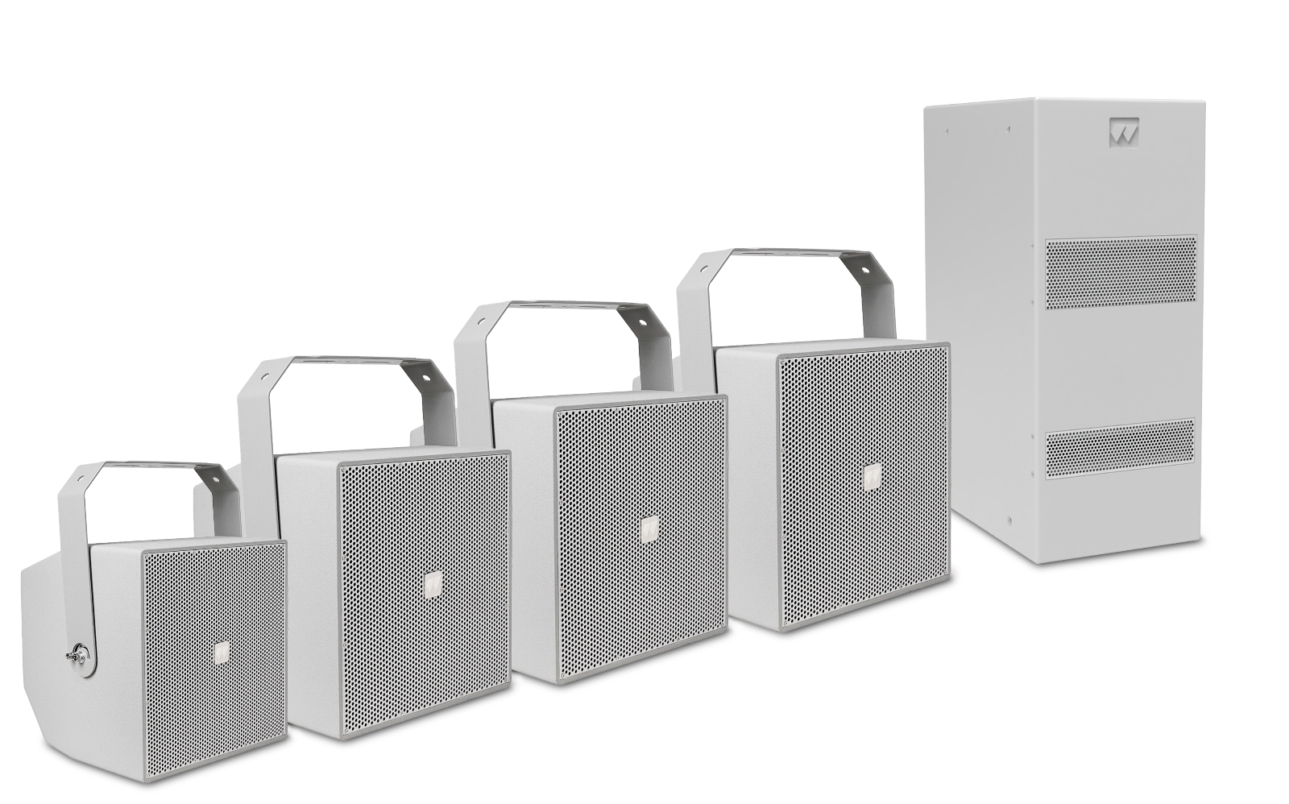
ARENA 28S
OVERVIEW
The ARENA Series compact coaxial loudspeaker system is designed to provide high quality sound reproduction in applications requiring extreme weather resistance. All cabinets are built from water-resistant polyvinyl board with tough texture coating. The hydrofobically-treated grill, moisture-sealed crossover and waterproof connector makes it reliable under long-term exposure to tough environmental conditions.
The ARENA Series consists of full range 6”/8”/10”/12” coaxial speakers and a dual 8” subwoofer.
Ideal for stadiums fairgrounds, outdoor entertainment centers, athletic fields, swimming pools background music, worships, multipurpose outdoor and indoor venues, etc.

Technical Data:
 | ARENA 6CX | ARENA 8CX | ARENA 10CX | ARENA 12CX | ARENA 28S
Power (Passive) | 300W | 360W | 400W | 600W | 800W
Impedance | 8Ω Nominal |  |  |  | 4Ω Nominal
70V | 60W/30W/15W/7.5W | 120W/60W/30W/15W | 200W/100W/50W/25W | - | -
100V | 60W/30W/15W | 120W/60W/30W | 200W/100W/50W | - | -
Transducer | LF: 1 x 6.5”, HF: 1” Compression driver (Coaxial) | LF: 1 x 8”, HF: 1” Compression driver (Coaxial) | LF: 1 x 10”, HF: 1-3/8” Compression driver (Coaxial) | LF: 1 x 12”, HF: 1-3/4” Compression driver (Coaxial) | LF: 2 x 8” band-pass
Connectors | Waterproof 4 pin connection system |  |  |  | 2 x 4 Pin XLN Speakon
Frequency response | 80Hz – 20KHz | 80Hz – 20KHz | 70Hz – 20KHz | 65Hz – 20KHz | 45Hz – 200Hz
Sensitivity | 97dB | 100dB | 105dB | 107dB | 95dB
SPL Max | 125dB | 128dB | 133dB | 135dB | 125dB
Dispersion | 110° x 110° (-10dB) | 110° x 110° (-10dB) | 95° x 95° (-10dB) | 60° x 60° (-10dB) | Omnidirectional
Cabinet construction | Water-resistant polyvinyl
Mounting | U Bracket |  |  |  | Metal stand mount on top
Finish | Texture coating
Grill | Steel with hydrofobically treated
Measures W/H/D | 256mm 275mm 251mm | 299mm 310mm 299mm | 330mm 370mm 330mm | 409mm 450mm 409mm | 208mm 450mm 670mm
Weight | 9.2Kg | 11.5Kg | 15.3Kg | 19,5Kg | 22.8Kg

FEATURES:
- Customized high performance woofer & compression driver.
- Built-in 70V/100V transformer with power tap switch (ARENA 6CX, 8CX & 10CX).
- Made of water resistant polyvinyl. IP54.
- Hidrophobically-treated Grill.
- Waterproof strip connector.
- U-bracket included for installation (ARENA 6CX, 8CX, 10CX & 12CX).
CONNECTIONS
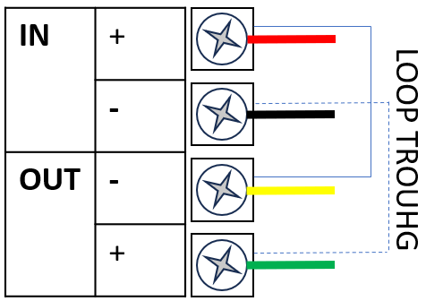

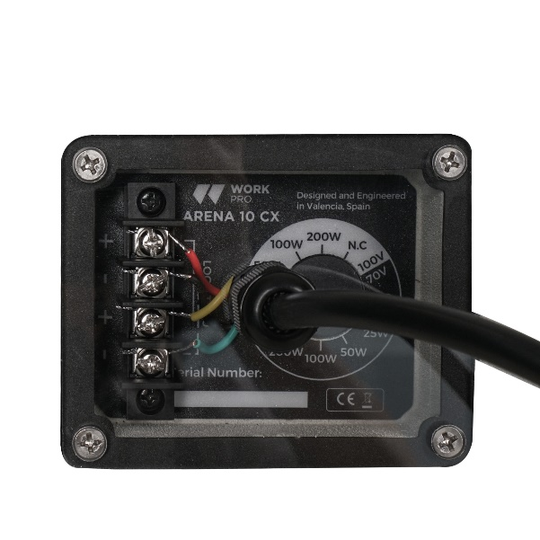
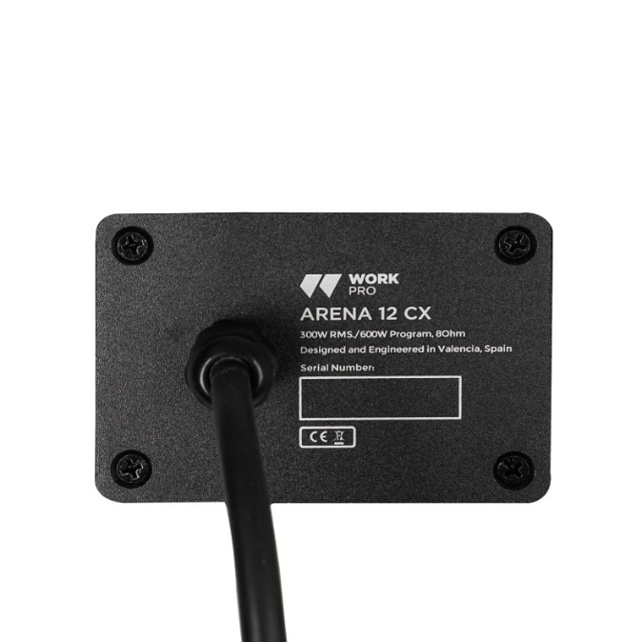

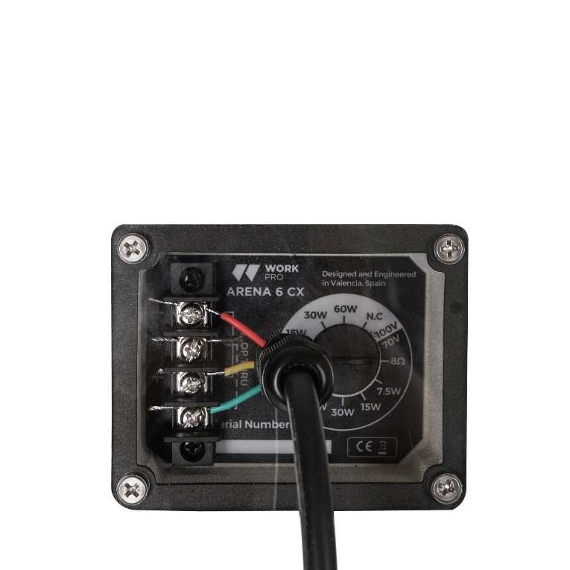
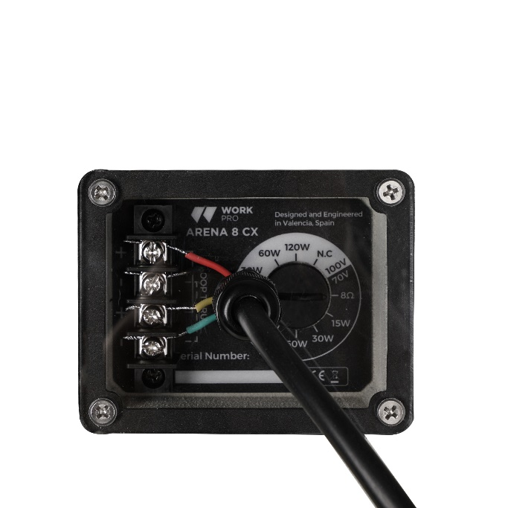

INSTALLATION
CAUTIONS
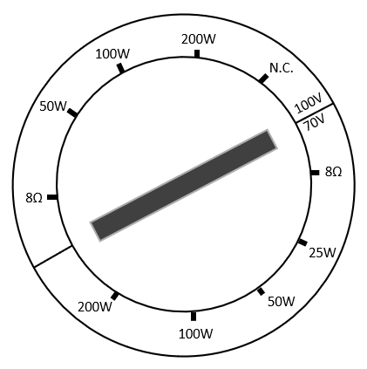



To connect to a 70/100V line speaker, select the desired power corresponding to its power, to connect to a low impedance speaker, select 8Ω.

MEASURES (mm):

ARENA 6CX
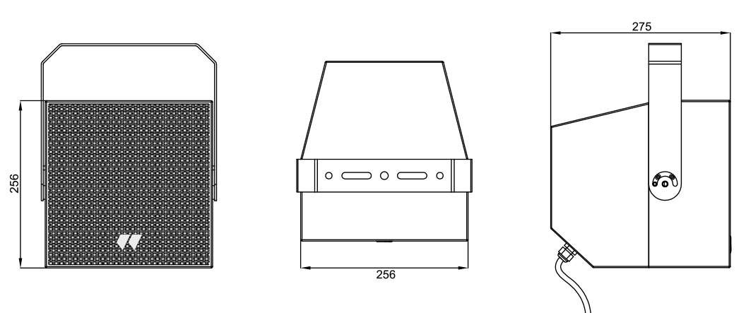

ARENA 8CX
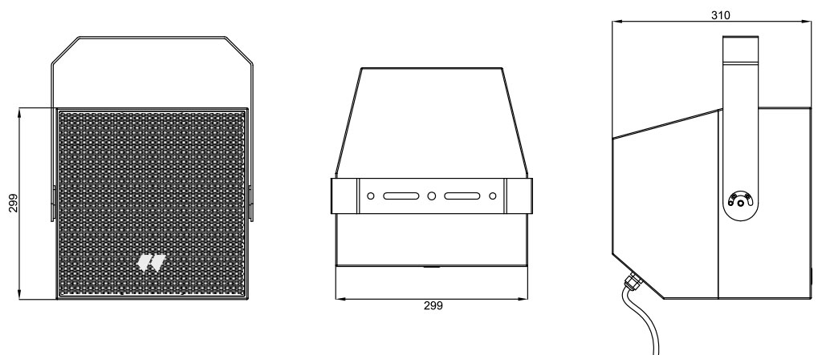

ARENA 10CX
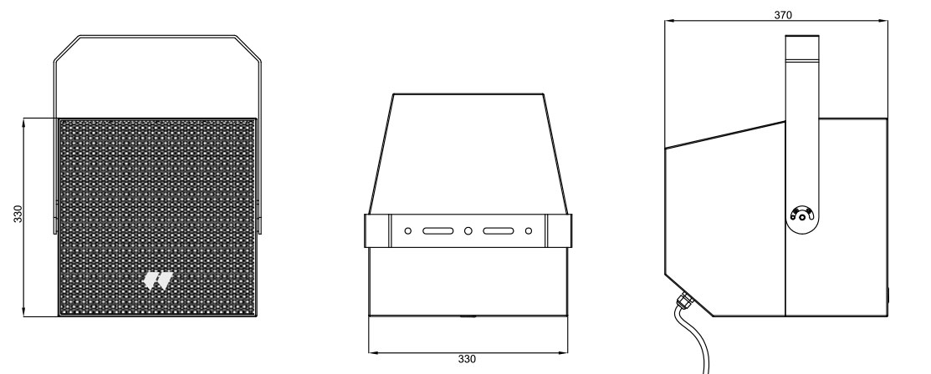

ARENA 12CX
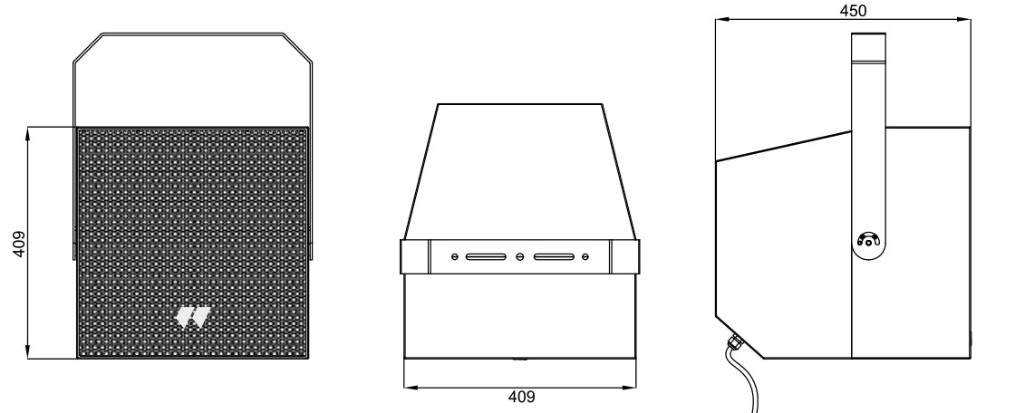

ARENA 28S
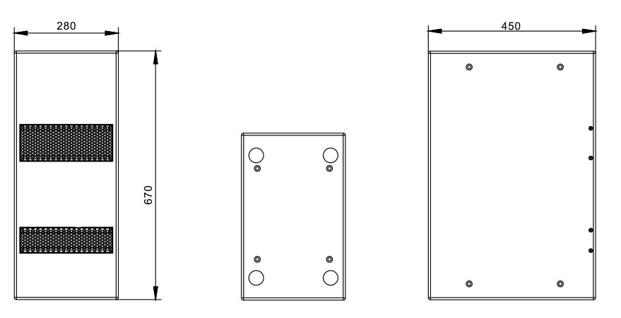

DESCRIPCIÓN GENERAL
La Serie ARENA de altavoces coaxiales compactos está diseñada para proporcionar una reproducción de sonido de alta calidad en aplicaciones que requieren una resistencia extrema a la intemperie. Todos los recintos están fabricados con tablero de polivinilo resistente al agua con un revestimiento de textura de alta calidad. La rejilla tratada hidrófobamente, el crossover sellado contra la humedad y el conector impermeable hacen que sea fiable bajo una exposición prolongada a duras condiciones ambientales.
La Serie ARENA consta de altavoces coaxiales de rango completo de 6"/8"/10"/12" y un subwoofer doble de 8".
Ideal para estadios, recintos feriales, centros de ocio al aire libre, campos de atletismo, piscinas, música de fondo, lugares de culto, espacios polivalentes de interior y exterior, etc.
Datos Técnicos:
 | ARENA 6CX | ARENA 8CX | ARENA 10CX | ARENA 12CX | ARENA 28S
Potencia (Pasiva) | 300W | 360W | 400W | 600W | 800W
Impedancia | 8Ω Nominal |  |  |  | 4Ω Nominal
70V | 60W/30W/15W/7.5W | 120W/60W/30W/15W | 200W/100W/50W/25W | - | -
100V | 60W/30W/15W | 120W/60W/30W | 200W/100W/50W | - | -
Transductor | LF: 1 x 6.5”, HF: 1” Compresión driver (Coaxial) | LF: 1 x 8”, HF: 1” Compresión driver (Coaxial) | LF: 1 x 10”, HF: 1- Compresión driver (Coaxial) | LF: 1 x 12”, HF: 1-3/4” Compresión driver (Coaxial) | LF: 2 x 8” Pasa Banda
Conexionado | Sistema de conexión impermeable de 4 pines |  |  |  | 2 x 4 Pin XLN Speakon
Respuesta en Frecuencia | 80Hz – 20KHz | 80Hz – 20KHz | 70Hz – 20KHz | 65Hz – 20KHz | 45Hz – 200KHz
Sensibilidad | 97dB | 100dB | 105dB | 107dB | 95dB
SPL Max | 125dB | 128dB | 133dB | 135dB | 125dB
Dispersión | 110° x 110° (-10dB) | 110° x 110° (-10dB) | 95° x 95° (-10dB) | 60° x 60° (-10dB) | Omnidireccional
Construcción del recinto | Polivinilo resistente al agua
Montaje | Soporte a pared en U |  |  |  | Soporte metálico superior
Acabado | Revestimiento texturizado
Rejilla | Acero con tratamiento hidrofóbico
Medidas An/AL/Pr | 256mm 275mm 251mm | 299mm 310mm 299mm | 330mm 370mm 330mm | 409mm 450mm 409mm | 208mm 450mm 670mm
Peso | 9.2Kg | 11.5Kg | 15.3Kg | 19,5Kg | 22.8Kg

Características:
- Woofer y driver de compresión de alto rendimiento.
- Transformador de 70 V/100 V incorporado con interruptor de selección de potencia (ARENA 6CX, 8CX & 10CX).
- Polivinilo resistente al agua. IP54.
- Rejilla con tratamiento hidrofóbico.
- Conector impermeable.
- Soporte en U incluido para la instalación (ARENA 6CX, 8CX, 10CX & 12CX).
CONEXIONES

INSTALACIÓN
PRECAUCIONES

Para conectar a altavoz a línea 70/100V seleccione a la potencia deseada correspondiente a su potencia, para conectar a altavoz en baja impedancia selecciona

MEASURES:

ARENA 6CX

ARENA 8CX

ARENA 10CX

ARENA 12CX

ARENA 28S

