

API for 3rd party
v.1.0


API
Assign IP: Stages leave the factory with the IP 192.168.64.100
Port: 7621

STRING TO SEND | DESCRIPTION | VARIABLE VALUES
POWER ON | NORMAL MODE | NONE
POWER OFF | STANDBY MODE | NONE
SET ZONE-X.MUTE Y\r\n | IF Y=1 MUTES ZONE X. IF Y=0 UNMUTES ZONE X | X[A,B,C,D] , Y[0,1]
SET ZONE-X.GAIN Y\r\n | SET ZONE X TO VOLUME=Y. Y CAN BE FROM MIN TO MAX | X[A,B,C,D] , Y[INT(MIN) to INT(MAX)]
SET OUT-X.GAIN Y\r\n | SET OUTPUT X TO VOLUME=Y | X[1,2,3,4] , Y[-30dB to 15dB]
SET OUT-X.MUTE Y\r\n | IF Y=1 MUTES OUTPUT X. IF Y=0 UNMUTES OUTPUT X | X[1,2,3,4] , Y[0,1]
SET OUT-X. SRC Y" | LINK OUT X TO ZONE Y | X[1,2,3,4] , Y[A,B,C,D]

EXAMPLE WITH HERCULES UTILITY

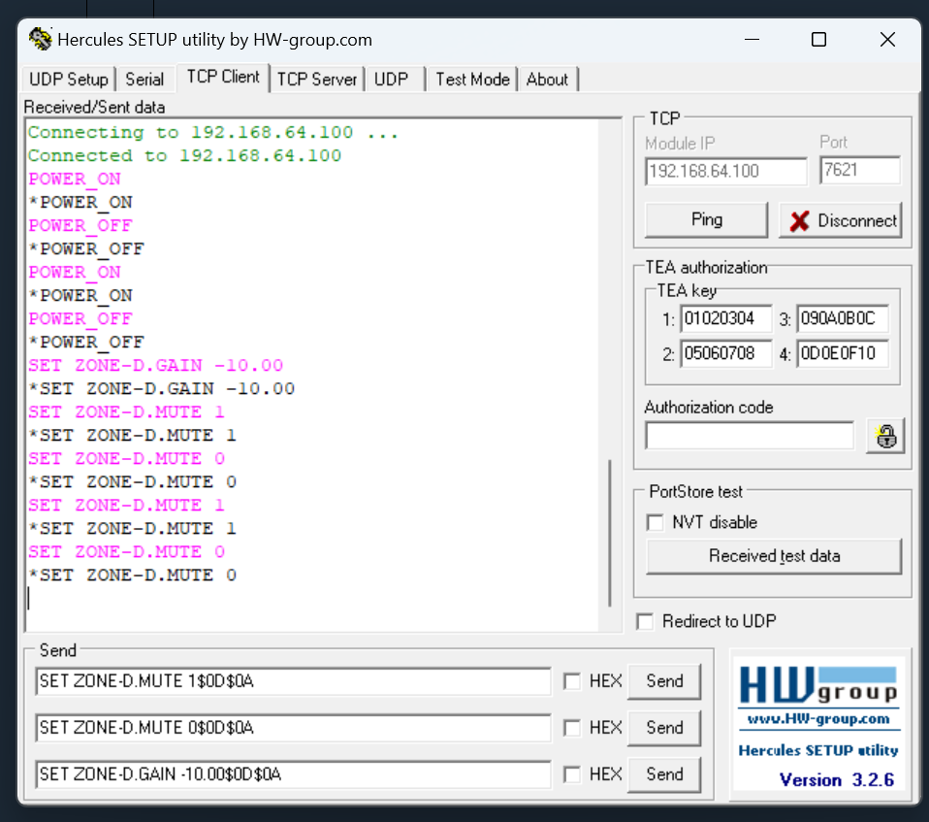

IN THIS PICTURE WE SEE:
SELECTED TCP CLIENT
DESTINATION IP (POWER AMPLIFIER): 192.168.64.100
DESTINATION PORT:7621
ALL STRINGS ARE FINISHED WITH $0d$0A THAT IS THE HEXADECIMAL REPRESENTATION OF \r\n.
FIRST COMMAND: SET ZONE D TO MUTE
SECOND COMMAND: SET ZONE D TO UNMUTE
THIRD COMMAND: SET ZONE D GAIN TO –10 dB



